Contents

Theme and Style 7

Visual Style 7

Character Style 8

References 9

Concept Sketches 10

World Style 11

References 12

Map Styles 14

The Future Proficient Soldier Academy 14

References 15

The Appendage Conservation Front Wing 16

References 17

The Academy Wing 18

References 19

The Society for Historical Beatdowns Wing 20

References 21

The Impossible Possibilities Wing 22

References 23

Scenes 24

Test Render: The Sorting Room 24

Models and Textures 27

Player Avatar 27

Weapons 28

Modifier Launcher 28

Nullifier Weapon 29

Pistol "The Small Bang" 29

Sniper Rifle "Binocular Sniper Rifle" 30

Explosive Projectile Weapon "Cannon Gun" 30

Assault Rifle "Fists of Fury" 31

Shotgun "Multi-Shot" 31

Damage over Time Weapon "The Composter" 32

Grenade "Pop Can" 32

Modifiers 33

Modifier Marker 33

Shrink Effect 33

Growth Effect 34

Wall Effect 34

Knockback Effect 35

Gravity Inversion Effect 35

Frictionless Effect 36

Increase Gravity Effect 36

Illusion Effect 37

Map: The Academy 38

The Appendage Conservation Front Wing 39

Sorting Room 39

Environment 39

Conveyor Belt 39

Wooden Body Part Boxes 39

Delivery Truck Rear 40

Categorization Signs 40

Windows 41

Flower Decorations "Diversi-pot" 41

Sorting Machine 42

Warehouse 43

Environment 43

Wooden Body Part Boxes 43

Categorization Signs 43

Armory Label 43

Warning Sign 44

Gun Racks 44

Part Piles 45

War Room 46

Environment 46

War Table 46

Battlefield Map 46

Wanted Posters 47

School Store 48

Environment 48

Bargain Bin 48

Reclaimed Crafting Supplies Bins 48

Register 49

Categorization Signs 49

Mannequin Displays 50

Clothing Racks 50

Dressing Room Door Facings 51

Emergency Room 52

Environment 52

Gurney 52

Marked Down Parts Boxes 52

Curtains 53

Ward Signs 53

Respawners 54

Academy Wing 55

The Higher Learning Arena 55

Environment 55

Learning Opportunity Decals 55

Grade Scoreboard 56

Cat Walks 56

The Classrooms 57

Environment 57

Chalkboard 57

Chairs 57

Rubble 58

Sandbag Wall 58

The Classroom Hallway 59

Environment 59

Lockers 59

Graded Shooting Targets 59

School Dance Poster 60

The Society for Historical Beatdowns Wing 61

The Museum 61

Environment 61

Classical Greek Airlock 61

Exhibit Posters 62

Cannon-wielding Exo-Skeleton (Optional) 62

Bowmerang Diorama (Optional) 63

ICBM Diorama (Optional) 63

Drapery (Optional) 64

Columns (Optional) 64

Impossible Possibilities Wing 65

Ground Level – Cubicles 65

Environment 65

Impossible Possibilities Sign 65

Welcome Desk 65

Cubicle 66

We Trust Our Employees Sign 66

Mannequin 67

Basement Level – Lab 68

Environment 68

Suits Warning Sign 68

Entrance Warning Light and Sign 68

Experimental Apparatuses 69

Test Subjects 69

Inverted Cubicle 70

Hide-able Lab Bench 70

Animations 71

Character Animations 71

Walk 71

Die 71

Jump 71

Fall 72

Invert 72

Grow 72

Shrink 72

Weapon Animations 73

Modifier Launcher 73

Nullifier Weapon 73

Pistol 74

Sniper Rifle 74

Explosive Projectile Weapon 75

Assault Rifle 75

Shotgun 76

Damage over Time Weapon 76

Grenade 77

# Theme and Style

**[Note: All sketches detail shapes and colors, not rendering style. See descriptions and references in Character and World Style sections for that information.]**

## Visual Style

Trigger Happy takes place in an absurd, whimsical, and comical Universe. The visual styling is meant to enable and amplify these feelings. The game's color palette is diverse, featuring distinctive colors that uniquely mark areas and characters.

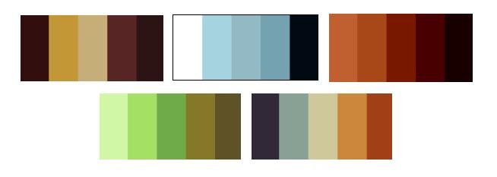

The rendering style is simple and iconic, focusing on recognizability over realism. Instead of wowing the player with ultra high quality representations of boring environments, we will devote our time to interesting, meaningful environments that capture the player's imagination. The model design will be focused on communicating its point quickly and distinctively. Not only is this important for creating a unique look, it is critical in styling something as fast paced as an FPS. To do this, we will be emphasizing the key parts of the environment through use of distinctive sizes, shapes, and colors. We will also simplify the texturing and geometry to move the player's focus from the rendering to the objects. Simplification should not be confused with low quality, however. It is a high quality style that uses a small number of colors and details to nonetheless capture the meaning of a texture or form (and even amplify its meaning through amplification by simplification).

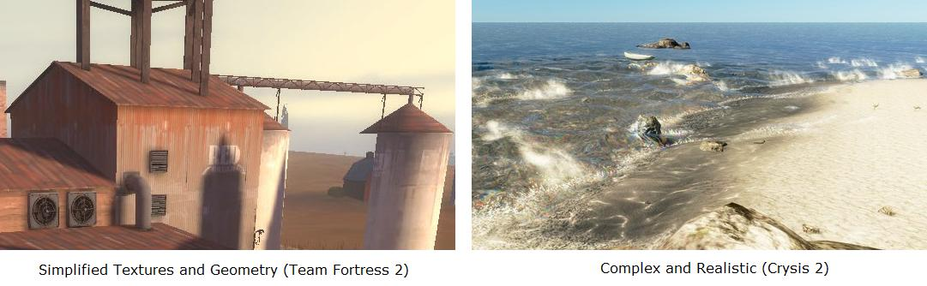

Another reason for choosing a more iconic, cartoonish style is the subject matter and tone of our game. Trigger Happy is designed to create comical and fun interactions. However, it is also a first person shooter featuring body part swapping. A realistic look would create mixed feelings as a result of these off putting topics. For some games, fully representing the gore adds to the design (such as a gritty war game), but for our fun and light feel it only detracts. Cartoon violence is appropriate because it sidesteps most of the real world consequences and shifts focus back on the inventions that we create for the game.

## Character Style

The player avatars in Trigger Happy are first and foremost normal, humanoid students. Second, they are FPS combatants that have little money. Their shape and clothing is a result of these two forces combined. Each team member wears a simple set of armor composed of scrounged parts such as pillows, sports pads, and cooking ware.

The characters' bodies are stylized instead of being anatomically correct. They are not cartoon characters interacting in a cartoon world, but they also aren't ultra realistic in the style of Call of Duty or Gears of War. Their forms are abstracted to smooth over the details of body hair, subtle musculature changes, wrinkles, and small joints. Their textures are low-frequency, simply detailed, and realistic in color. The character models are lit to emphasize their silhouette, which means brightening the model's border in comparison to the interior. Shadows will be modified to rapidly fall off, creating defined shadow areas on the body.

### References

Sniper – Team Fortress 2

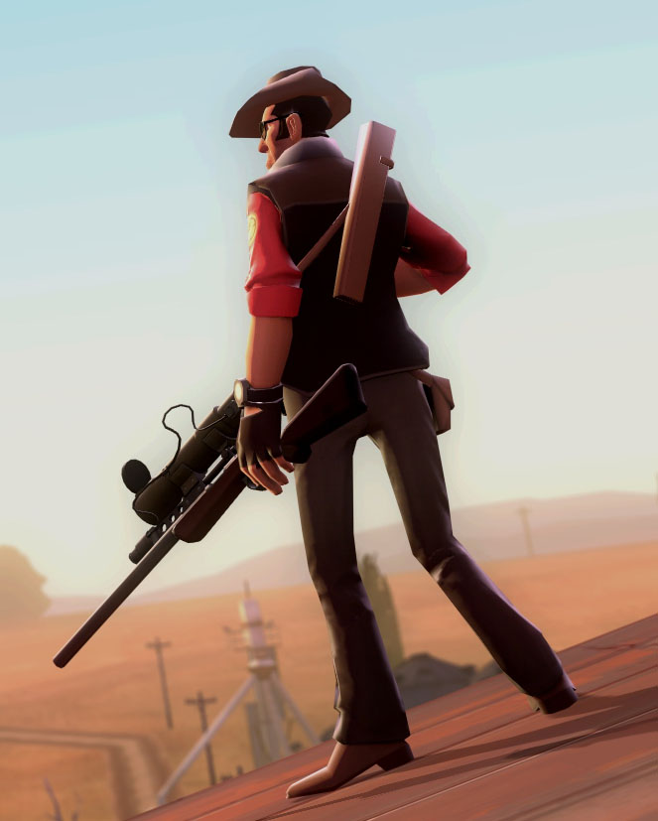

**Relevant Parts:** Distinct border. Simple textures. Abstracted body shape. Slight, cartoonish feel.

Human Female – World of Warcraft

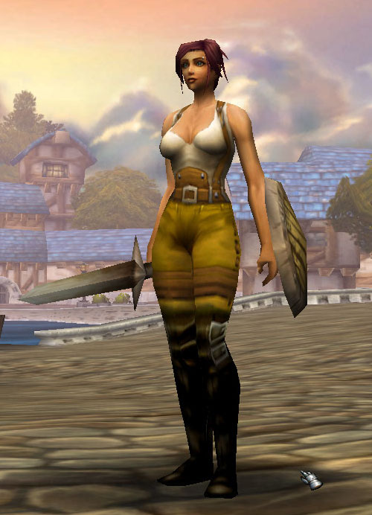

**Relevant Parts:** Abstracted, idealized body shape. Realistic, but also lower detail, simplified textures.

### Concept Sketches

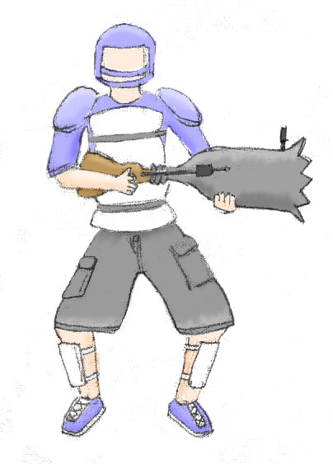

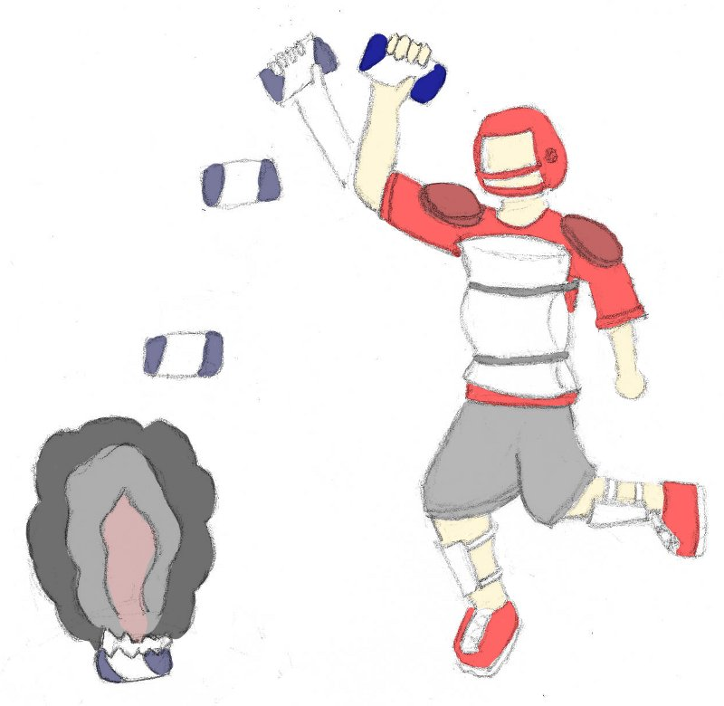

## World Style

The world of Trigger Happy is designed to mesh with the appearance of the characters and the comical feel of the game. It is represented in a naturalistic style but with much of the detail abstracted away. Textures are simplified, low-noise, featuring broad strokes of color derived from more detailed base textures. Only as much detail as is needed to communicate the object's material is provided. The color choices will reflect the palettes of the areas that the objects reside in. Objects are modeled with low complexity. They are never shiny or reflective, instead using diffuse lighting. They are meant to communicate their purpose quickly and effectively. The general feeling is simple and clean from a visual perspective. Interest is generated though the content of the objects instead of the rendering.

Below is the result of transforming a source texture into a texture matching our style. It involves abstraction, smoothing, and then flattening and desaturating the colors without losing the significant details that define the texture.

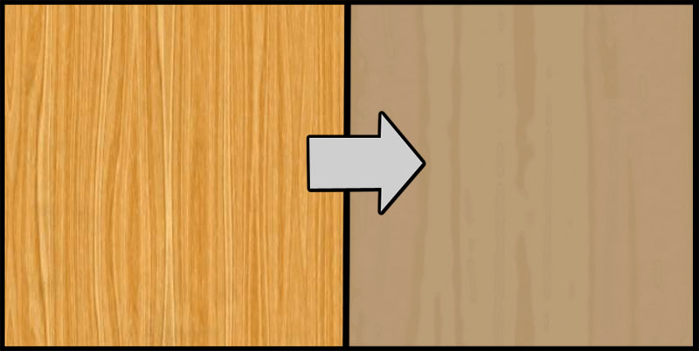

### References

Warsow

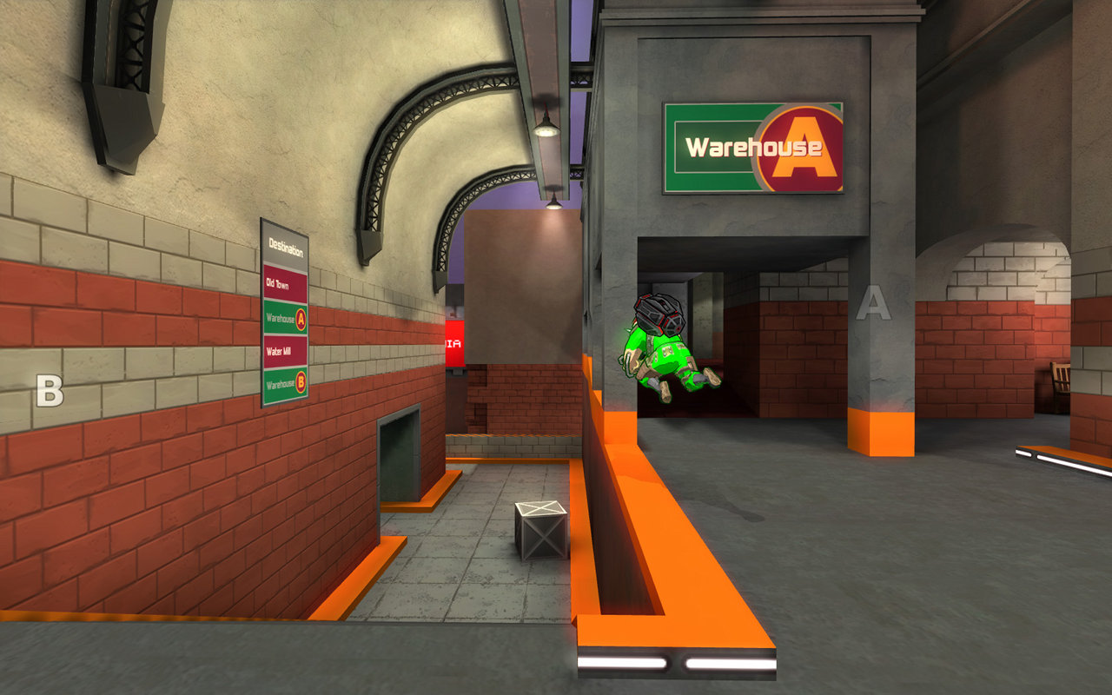

**Relevant Parts**: Textures that prioritize shape and color over high frequency detail. Simple geometry.

<http://www.warsow.net/media/0.5/1280px/01.jpg>

Team Fortress 2

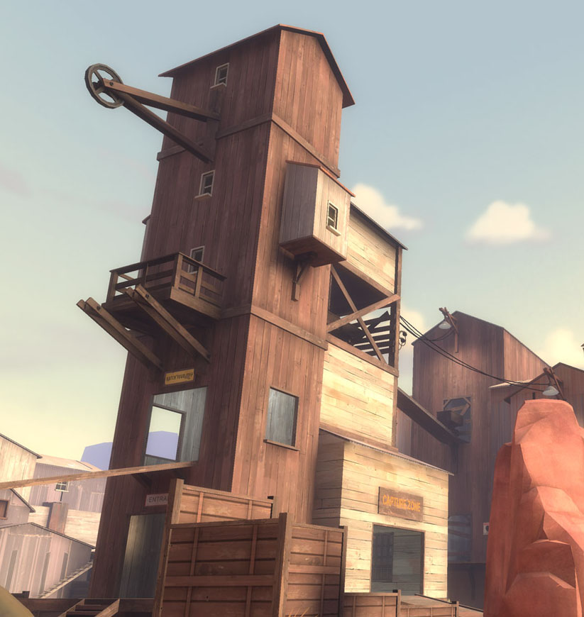

**Relevant Parts**: The painterly quality of the textures. The angular and orthogonal lines. The eye catching layout of the geometry.

<http://evilwombat.files.wordpress.com/2008/08/05_ravine_2.jpg>

# Map Styles

## The Future Proficient Soldier Academy

The Academy is built into an old, stone fort that has been decaying for several hundred years. It is two stories tall with additional space in a spooky, catacomb-like basement area. Its rooms and corridors are in various states of disrepair, ranging from surface damage, to structural damage, to complete collapse. Some parts have been patched up with new or found materials, but most have not. The original rooms of the fort have mostly been converted over to new purposes for use in the school. For example, the armory now stores spare part boxes as a warehouse, while the dungeons have been re-purposed as a hidden experimentation area.

Attached to the fort is a new research lab built by the fabulously rich Impossible Possibilities Corporation. Unlike the rest of the school, it is built from high quality futuristic materials. In fact, the entire city surrounding the Academy is more like the research lab than the fort. The only reason that the fort and its grassy grounds exist in the modern architectural age is that universal historical preservation laws prevent its outright destruction.

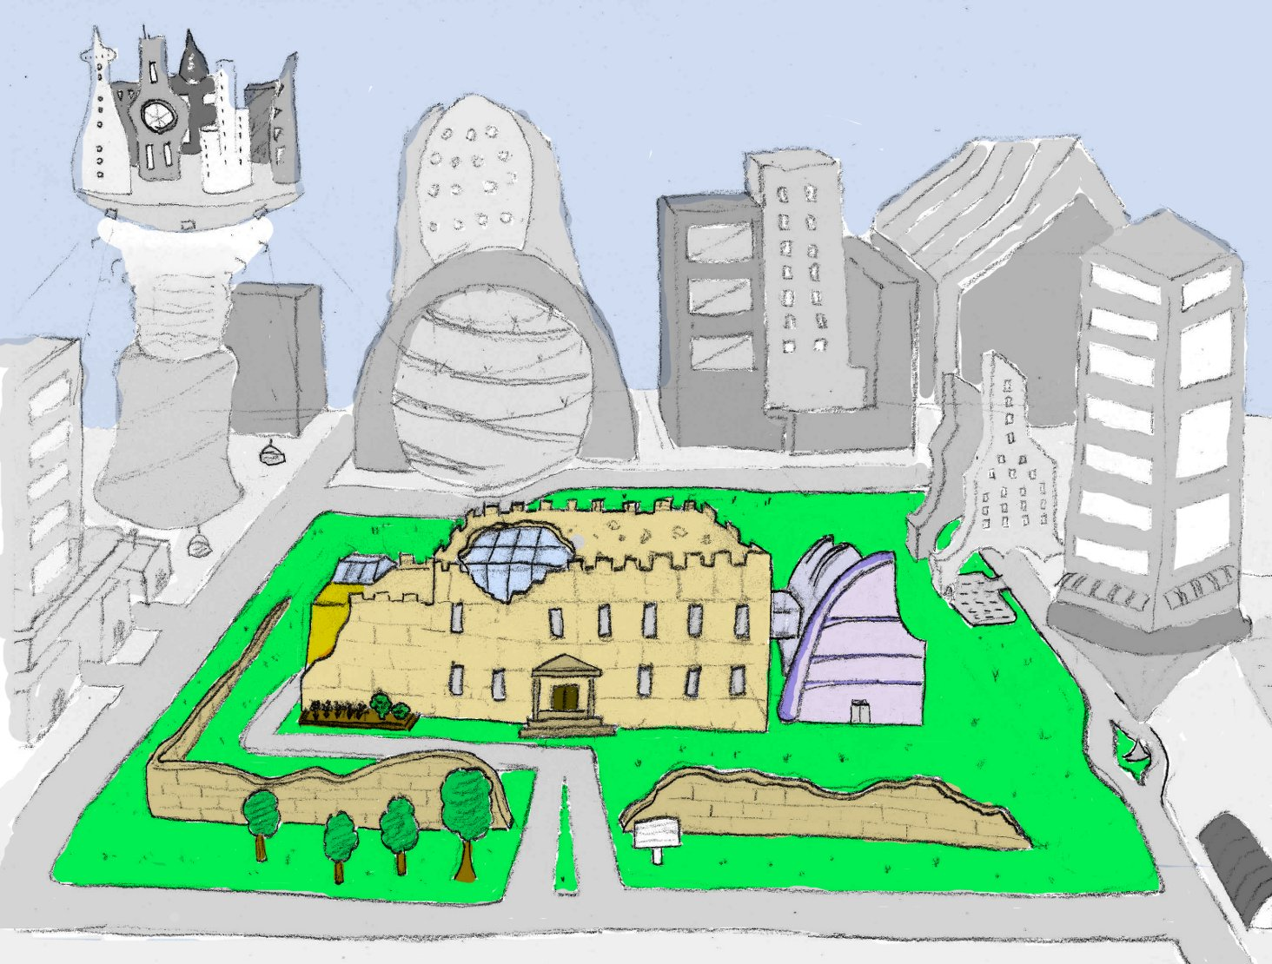

### References

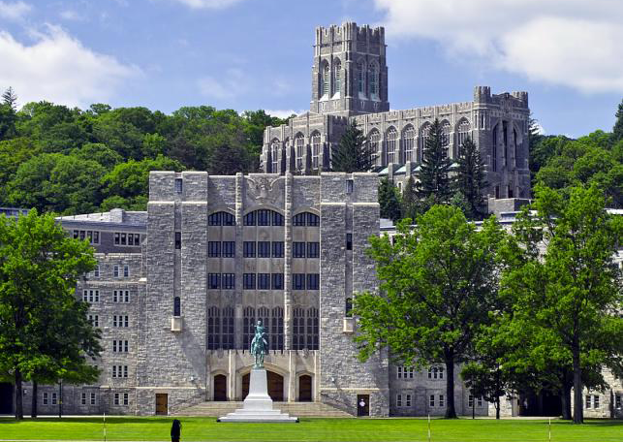

## The Appendage Conservation Front Wing

The Appendage Conservation Front Wing is half dedicated to ACF work and half dedicated to their school support activities. It is styled in a bright and cheery way, which is meant to be juxtaposed with its morbid work. It is the wing with the most windows, light, and airy space. The decorations placed throughout the wing are mostly natural or do-it-yourself kind of objects though there is machinery when it cannot be helped. For example, their conveyor belts are mostly metal and rubber, but the holes in them have been repaired with cloth patches that betray hand stitching. The walls are partially fort stone, but it is vine covered in places. There is a prodigious amount of signage advertising environmentally friendly practices. Any repair work done here is done using sustainable materials like wood or clay.

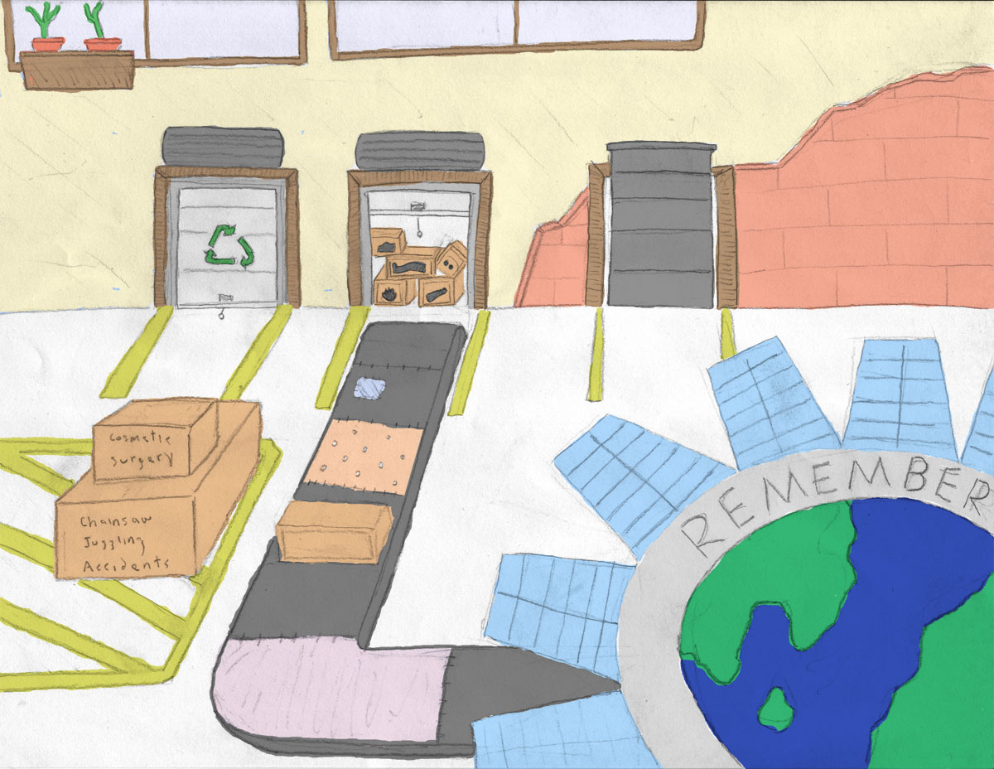

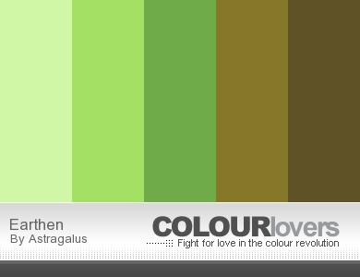

### References

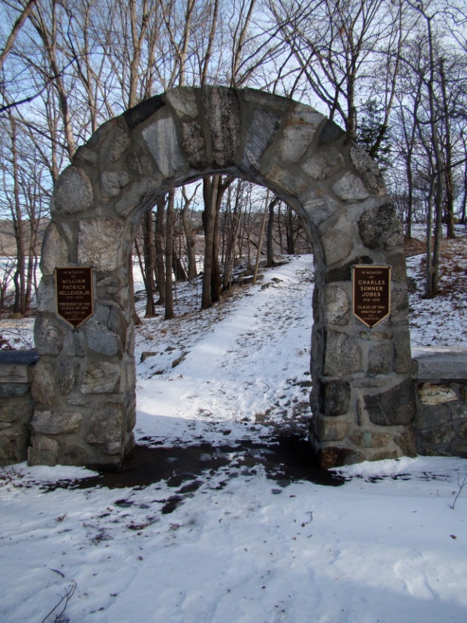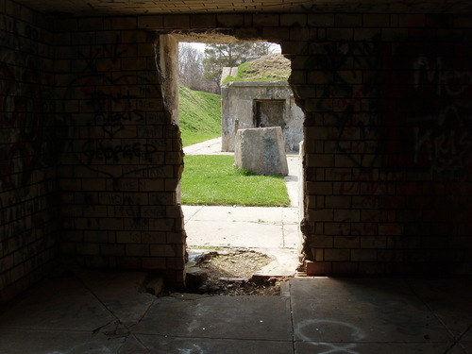

## The Academy Wing

The Academy Wing is housed in the fort training area. This area is composed of a number of training rooms and a large courtyard that was used for doing military exercises. It is styled in a semi-scholastic fashion, with notable differences that separate it from a standard school look. These differences are largely drawn from a vast store of first-person shooter objects and training items. The point isn't so much to mock a FPS as it is to create an environment where students can learn about this type of combat. As such, every cover spot, spawn location, and capture point is a labeled learning opportunity. The materials here are rubber for the training arena, and stone for the classrooms. The classrooms contain a mix of rugged training gear and standard school gear like chalkboards and class rules.

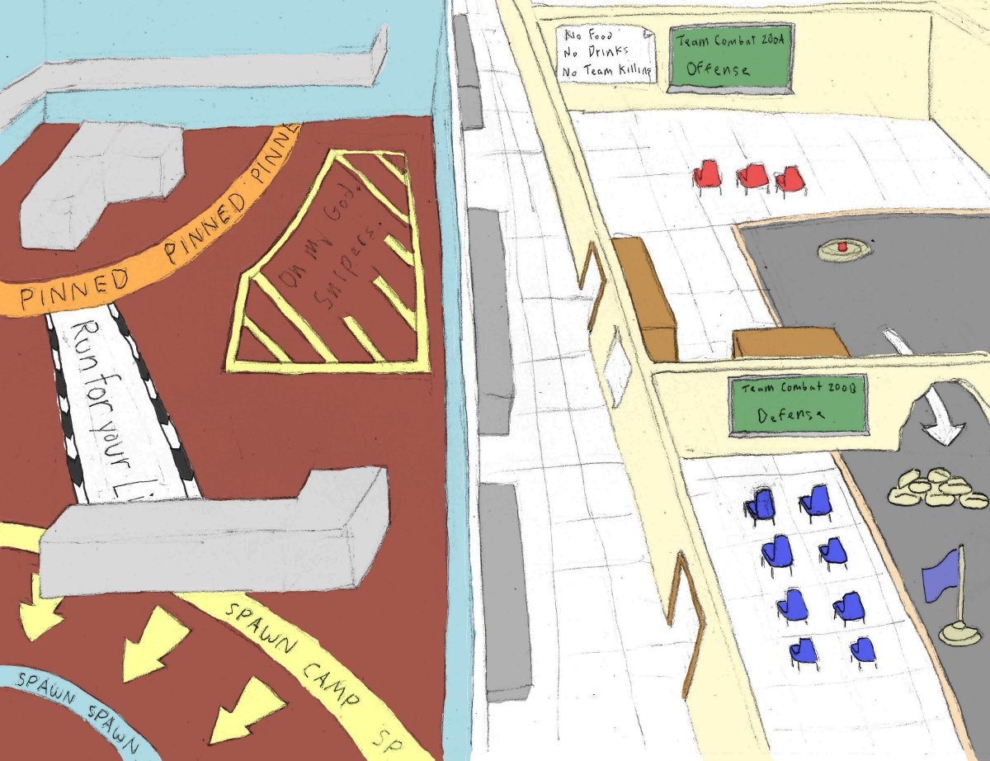

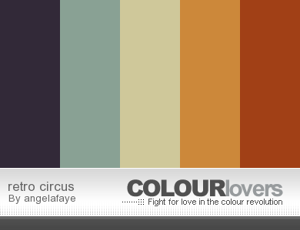

### References

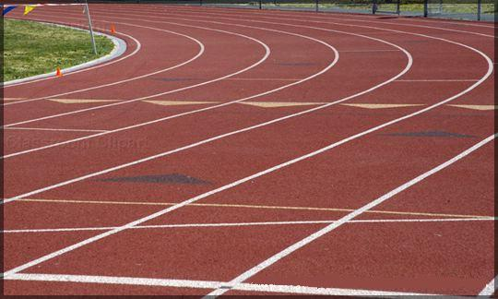

<http://www.jewell.edu/william_jewell/gen/william_and_jewell_generated_bin/images/basic_module/track.jpg>

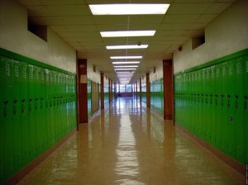

<http://www.paranormalknowledge.com/wp-content/uploads/2009/07/high-school-hallway-300x224.jpg>

## The Society for Historical Beatdowns Wing

This wing is located behind the Academy wing inside of a large, two-story tall room. It constructed as a museum, and is filled with relics of our military history; however, their purposes of are grossly misinterpreted. The general look of this wing is one of cheaply purchased luxury obscuring serious faults in the building. Columns hide crumbling supports. Velvet curtains hide destroyed sections of wall. The only windows in the wing are covered in heavy, protective steel bars. However, despite all of this, the professors are immensely proud of their creation.

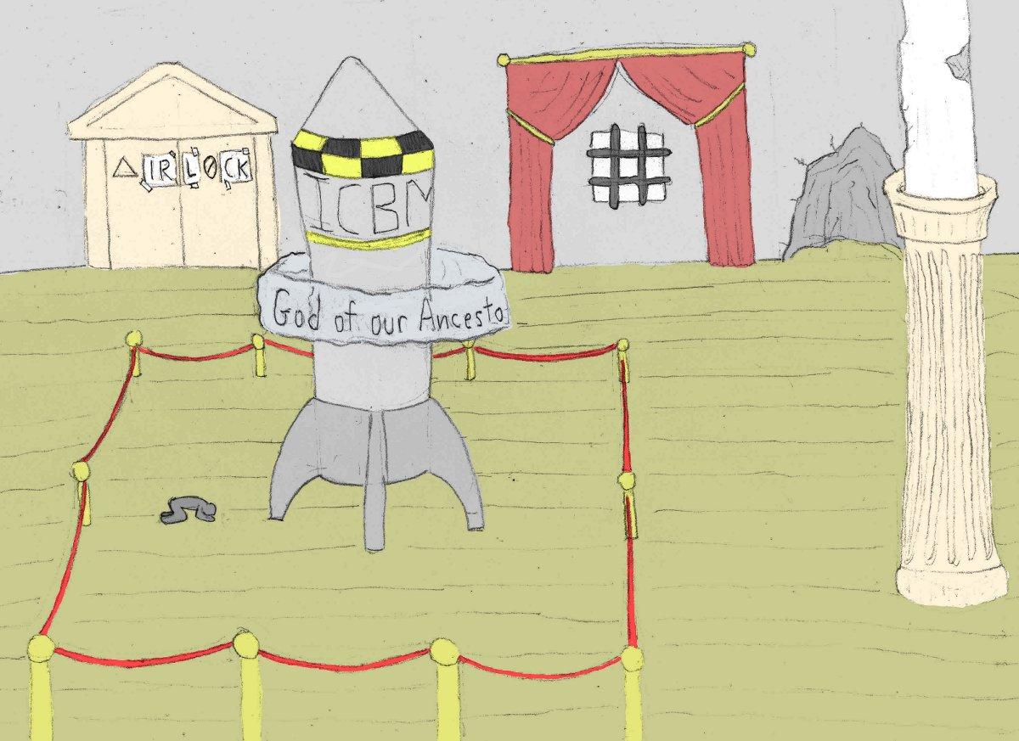



### References

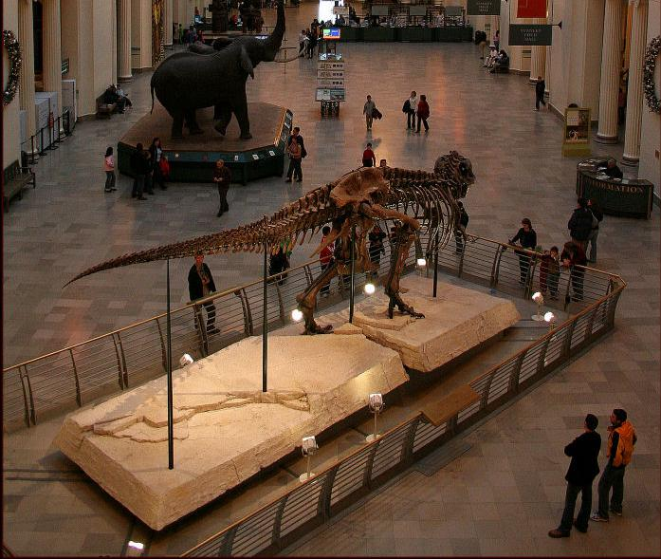

<http://www.lensimpressions.net/index.php?showimage=515>

## The Impossible Possibilities Wing

The Impossible Possibilities Wing has a split personality. Upstairs it is the only futuristic looking location in the entire academy. Materials like glass and stainless steel dominate. Object float, hang, and sparkle in the sun. Even the cubicles are built from transparent displays. However, this luxury comes at a price. The entire floor is under heavy, automated observation by the parent corporation. Big brother is present in all of the hidden and not so hidden niches. Luckily, the lab staff and students have a place where they can work unobstructed. The basement of this wing taps into the dungeons of the fort. In this spooky environment, modern technology mixes with ancient stockades. The combined look is an accidental mad scientist’s lab set in a dimly lit underground cavity.

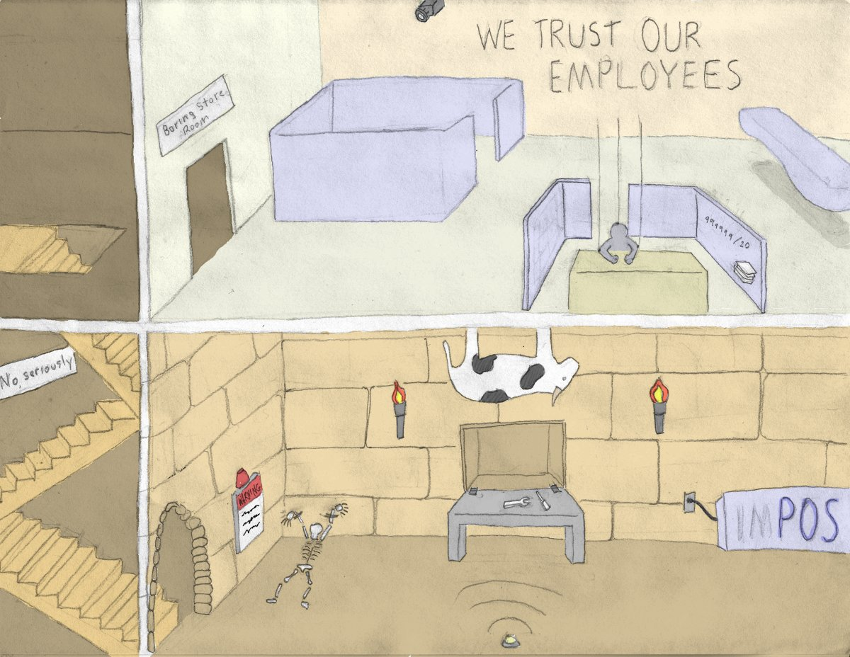

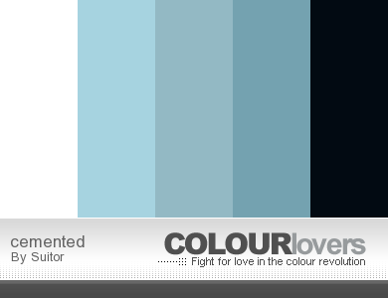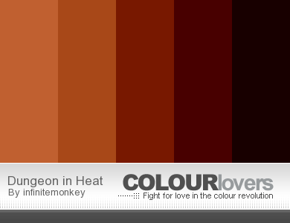

### References

Ground Level Cubicles

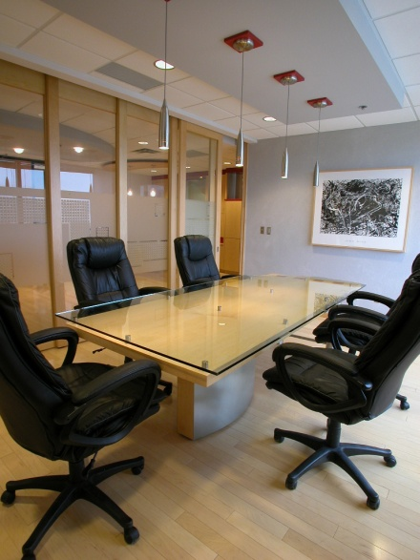

<http://www.peterallenco.com/DSCN0095.JPG>

Basement Lab

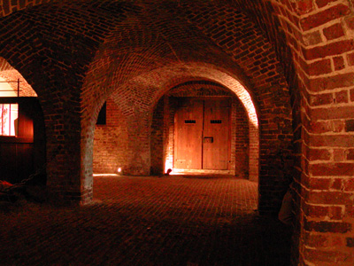

<http://dolinsky.fa.indiana.edu/caveart/spr09/jcterzin/jct_dungeon1.jpg>

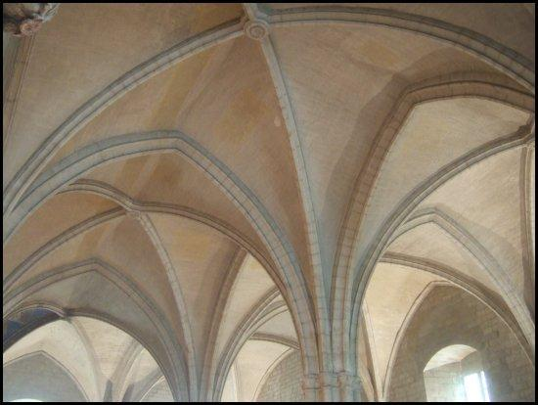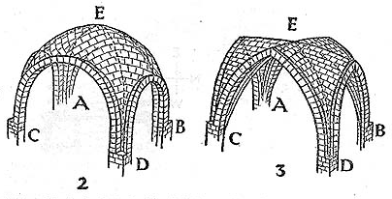

# Scenes

## Test Render: The Sorting Room

For details on the layout, see the Models and Textures section.

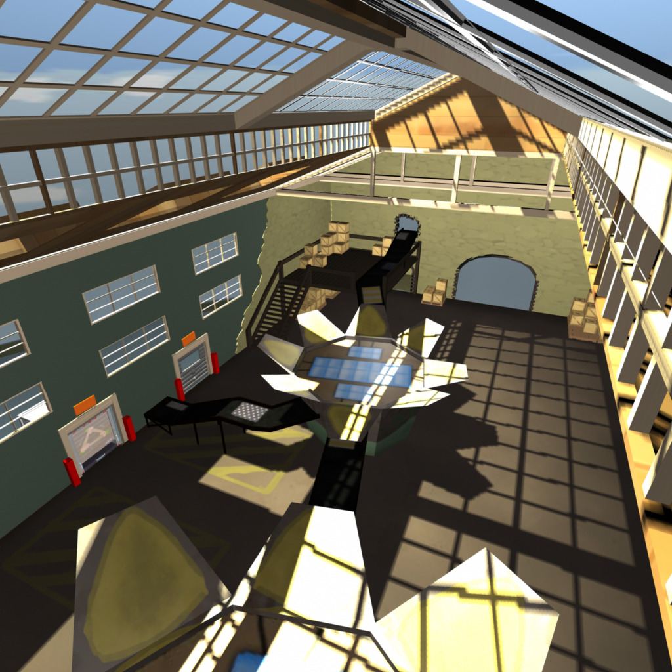

Figure : Wideshot from the ceiling.

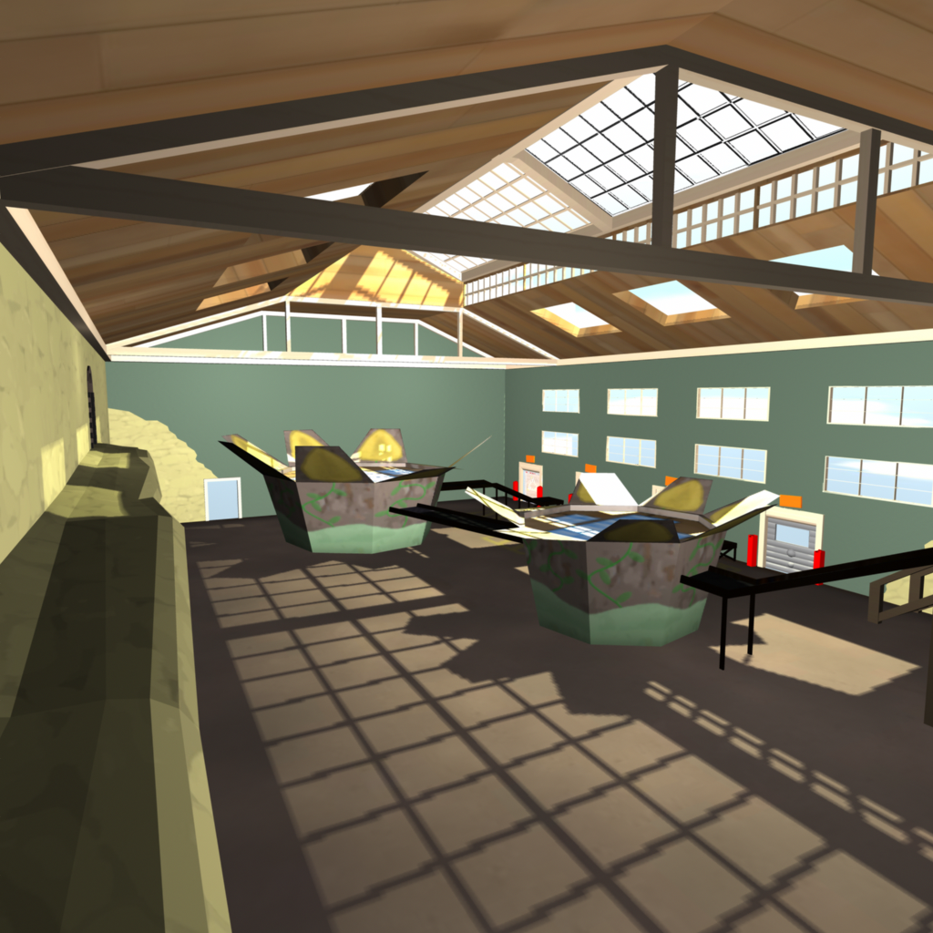

Figure : From the ledge.

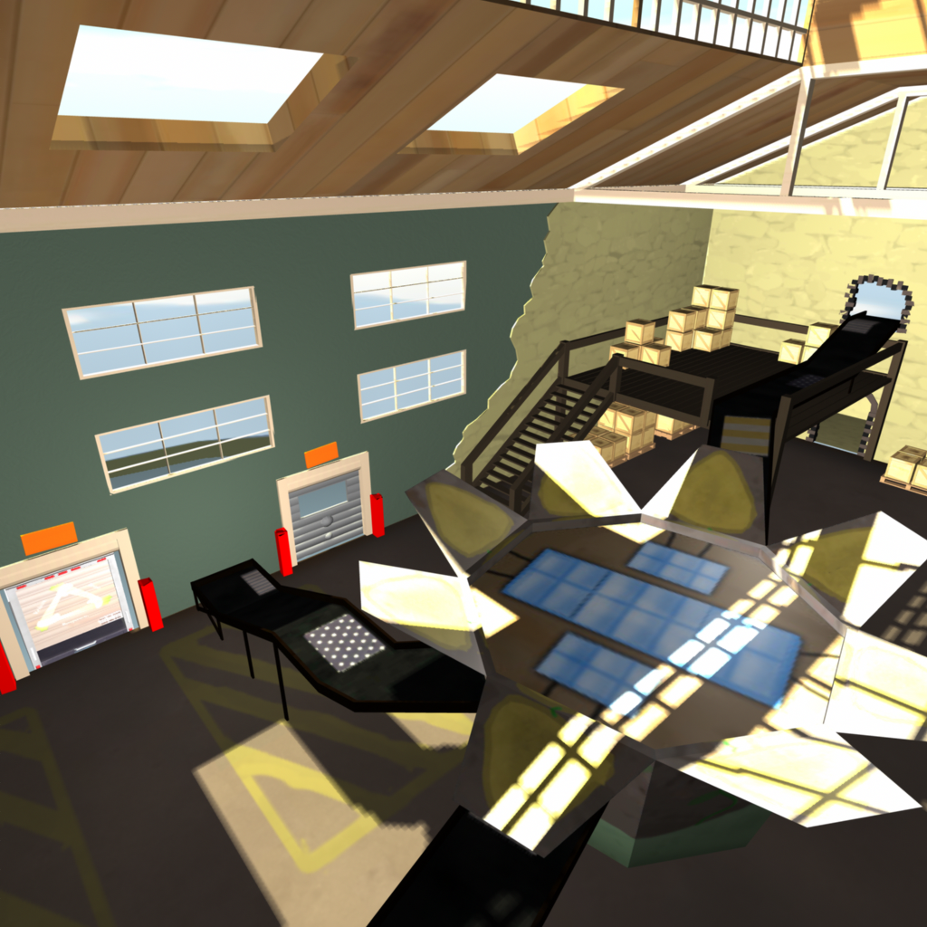

Figure : The sorting machine and conveyors.

# Models and Textures

Each asset is rated according to three criteria:

* Gamplay Importance [5 most – 1 least] – How much losing this asset would affect the gameplay (level flow, not having a weapon to fire, etc.).
* Art Importance [5 most – 1 least] – How much losing this asset would affect the ability of the game to convey story and style.
* Simplifiable? - Can the geometry and textures be simplified or is it critical that this asset appear exactly as stated.

## Player Avatar

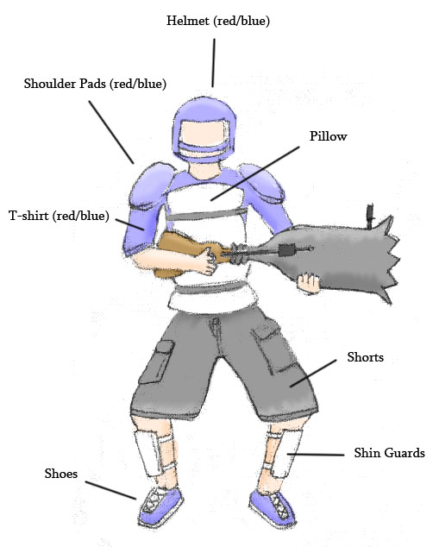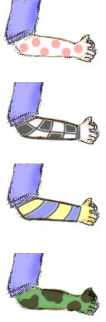

* Meshes
  + A medium-build humanoid with shoes and shin guards.
  + A t-shirt attached to torso.
  + A pair of shorts attached to lower body.
  + A set of shoulder pads.
  + A football style helmet.
  + A pillow attached to the torso.
* Textures
  + Body parts
    - Left Arm
    - Right Arm
    - Left Leg
    - Right Leg
    - Head
    - Hand
  + Team Colored Items (red and blue coloring)
    - Helmet
    - Shoulder Pads
    - T-shirt
    - Shoes
  + General Items (one coloring)
    - Grey Shorts
    - White pillow.
    - White Shin guards.

## Weapons

#### Modifier Launcher

* *Description:* A metal lunch box like container that holds the modifiers. Decorated with the "Mod Crew" logo (70s theme) and various technical components (radar dish, etc).
* *Quality:* High.
* *Use*: Fires the modifiers.
* *Importance:* Gamplay (5). Art (3). Can be simplified.

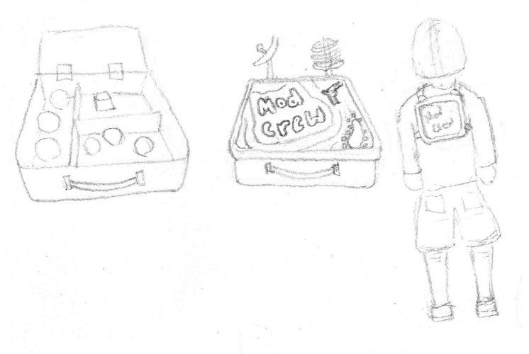

#### Nullifier Weapon

* *Description:* A remote control-like device made from a pocket calculator and an antenna. The button is large and red.
* *Quality:* High.
* *Use*: Held in one hand by the player.
* *Importance:* Gameplay (5). Art (3). Can be simplified to a remote with only a single button.

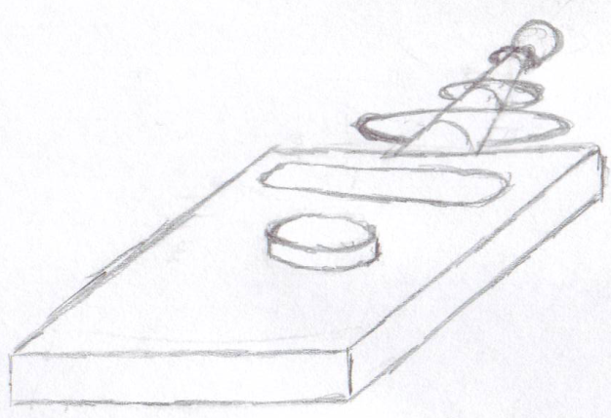

#### Pistol "The Small Bang"

* *Description:* A modified pop gun. Augmented with small pistons to work the pumping motion. Constructed from a fine grained wood material.
* *Quality:* High.
* *Use*: Shoots normal and flaming ping pong balls.
* *Importance*:Gameplay (5). Art (4). Can be simplified to a basic pop gun.

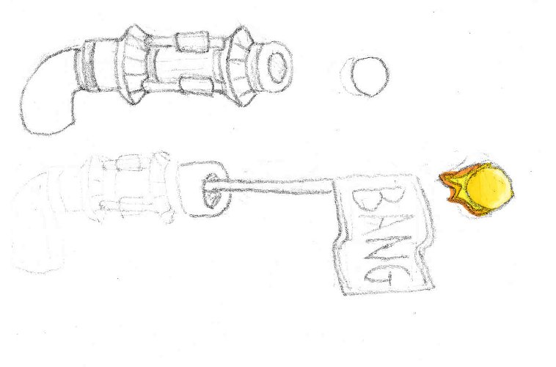

#### Sniper Rifle "Binocular Sniper Rifle"

* *Description:* A compact sniper rifle mounted inside a pair of binoculars. The left ocular contains the barrel while the right ocular contains the scope. There are two triggers, one on each ocular where the hands hold.
* *Quality:* High.
* *Use*: Held with two hands. Each on the triggers of the binocular scopes.
* *Importance*:Gameplay (5). Art (3). Can be simplified a small amount, but the scope and barrel much remain.

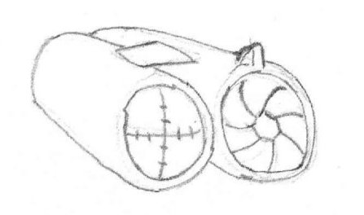

#### Explosive Projectile Weapon "Cannon Gun"

* *Description:* A blunderbuss widened at the end to fire explosive cannon balls. Augmented with shock absorbers, one on each side and a joint spring in the middle. Features a large crosshair sight on the end of the barrel.
* *Quality:* High.
* *Use*: Held with two hands. One on the trigger, one on the stock.
* *Importance*:Gameplay (5). Art (3). Can be simplified as long as it maintains its shape and joint spring.

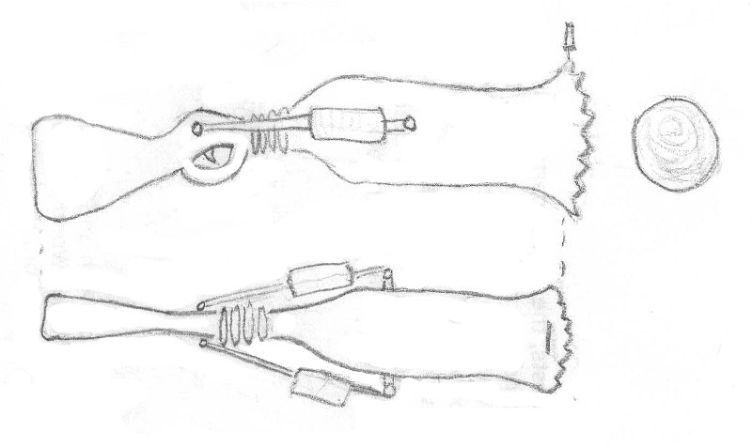

#### Assault Rifle "Fists of Fury"

* *Description:* A gun that fires unusable hands in the form of fists. It feeds from a parts box and projects them from a steel tube.
* *Quality:* High.
* *Use*: Held with two hands. One on the stock, one on the trigger.
* *Importance*: Gameplay (5). Art (4). Cannot be simplified.

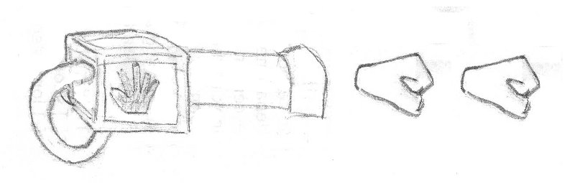

#### Shotgun "Multi-Shot"

* *Description:* Many single shot guns taped together. They reload at different frequencies.
* *Quality:* High.
* *Use*: Held with two hands. One on the stock, one on the trigger.
* *Importance*: Gameplay (5). Art (2). Can be simplified or outright changed.

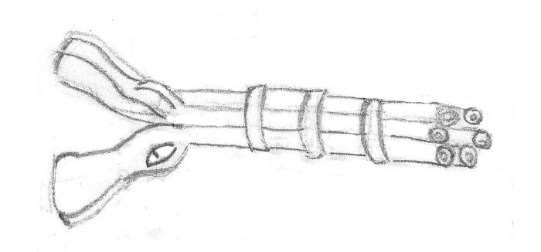

#### Damage over Time Weapon "The Composter"

* *Description:* A solar powered heat ray gun, powered by an energy efficient CFL. Over-driven version of a tool used for composting and moving soil. A solar panel is mounted on its back; while an array of focusing lenses sit on the top.
* *Quality:* High.
* *Use*: Held with two hands. One on the stock, one on the trigger.
* *Importance*:Gameplay (5). Art (4). Can only be simplified very little without losing its meaning.

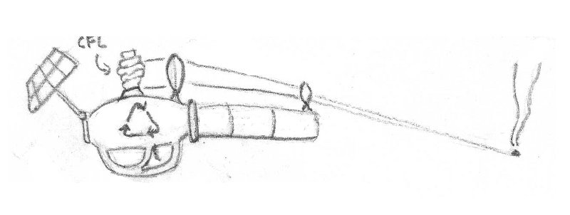

#### Grenade "Pop Can"

* *Description:* A soda can filled with explosives. Triggers shortly after the tab is popped. Explodes in a fireball.
* *Quality:* High.
* *Use*: Held with one hand.
* *Importance*: Gameplay (5). Art (2). Cannot be simplified.

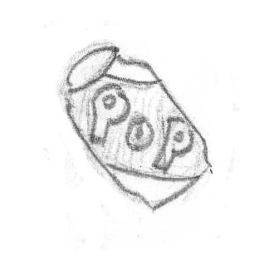

### Modifiers

#### Modifier Marker

* *Description:* An X shaped decal marking where a modifier is. Colored to almost but not quite blend in with the environment. Appears to be made from tape.
* *Quality:* High.
* *Use*: Placed to mark where a modifier is deployed.
* *Importance*: Gameplay (5). Art (2). Cannot be simplified.

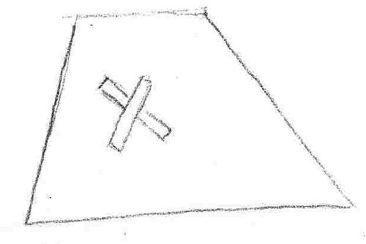

#### Shrink Effect

* *Description:* A portal appears 6 feet along the normal of the surface that the modifier is on. A large hand or dinosaur foot stomps downward crushing the player for the duration. The portal features a swirl distortion and is textured like a star field.
* *Quality:* High.
* *Use*: Triggered when a Shrink modifier goes off.
* *Importance:* Gameplay (5). Art (4). Can be simplified as long as it intuitively represents crushing or shrinking.

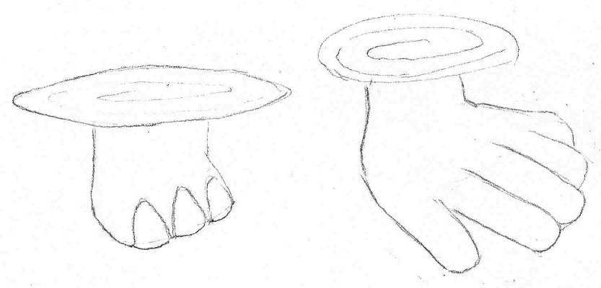

#### Growth Effect

* *Description:* A large radiation symbol glowing with unnatural orange light. Indicative of mutating radiation.
* *Quality:* High.
* *Use*: Appears when the Grow modification is triggered. Causes the player model to get bigger as described in the Grow animation.
* *Importance:* Gameplay (3). Art (4). Can be simplified as long as it communicates the idea of growth.

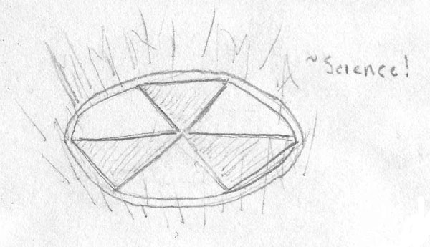

#### Wall Effect

* *Description:* A wall make of transparent wood planks. It is as tall as a player and twice as wide. Has depth equal to twice a player's depth. An opaque sign on the front says "Trespassers will be Shot." It pops up from the modifier’s surface along the surface normal.
* *Quality:* High.
* *Use*: Triggered when a wall modifier is activated.
* *Importance*: Gameplay (5). Art (3). Can be simplified as long as it blocks the player’s path but not their view.

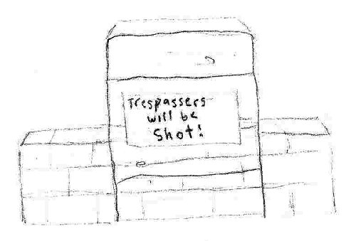

#### Knockback Effect

* *Description:* An explosion of confetti and streamers.
* *Quality:* High.
* *Use*: Triggered when the knockback modifier is activated.
* *Importance*: Gameplay (3). Art (3). Can be simplified as long as it communicates the idea of an explosion.

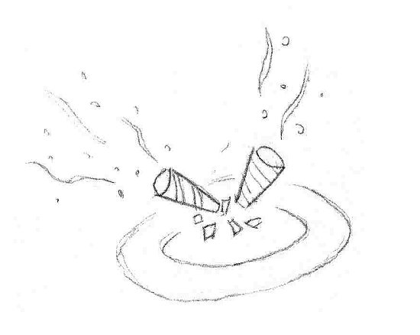

#### Gravity Inversion Effect

* *Description:* A wormhole-like swirl extends from the modifier location upwards along the current gravity vector. Animates to show the swirl like a small, thin disk moving up a barbershop pole.
* *Quality:* High.
* *Use*: Triggered when a gravity inversion modifier is activated.
* *Importance*: Gameplay (4). Art (3). Can be simplified as long as it points the direction of the player’s movement.

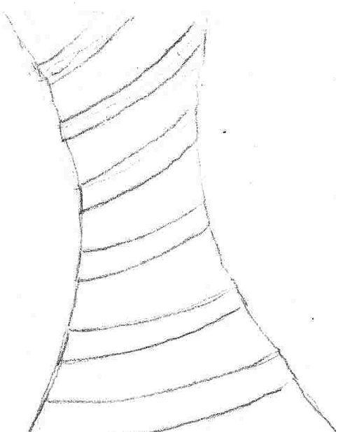

#### Frictionless Effect

* *Description:* Replace the player's lower body clothing with a pair of footie pajamas.
* *Quality:* High.
* *Use*: Swapped into the model texture when the player is under the effect of the Frictionless modifier. Does not interrupt the player's running leg animations.
* *Importance:* Gameplay (5). Art (2). Cannot be simplified.

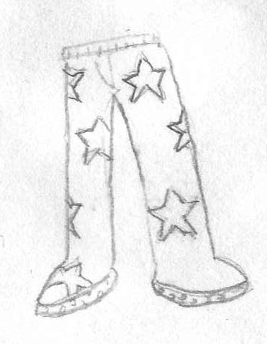

#### Increase Gravity Effect

* *Description:* Two planetoid-like objects circle the player in perpendicular orbits.
* *Quality:* High.
* *Use*: Appear when the player is under the effect of the Increase Gravity effect.
* *Importance*: Gameplay (5). Art (3). Can be simplified as long as it communicates increased weight.

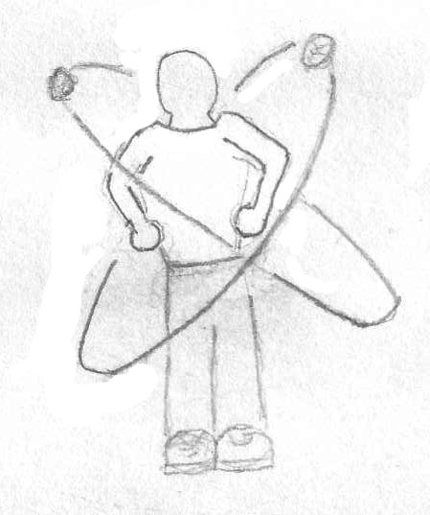

#### Illusion Effect

* *Description:* Spawns several copies of the player's model to distract enemies. Appears just like a player avatar.
* *Quality:* High.
* *Use*: Appear when the Decoy modifier is activated.
* *Importance*: Gameplay (5). Art (3). Cannot be simplified.

**Consult the Player Avatar section for concept art.**

### Map: The Academy

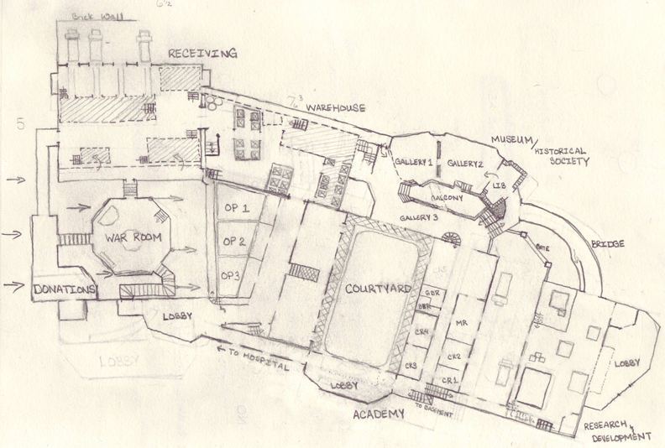

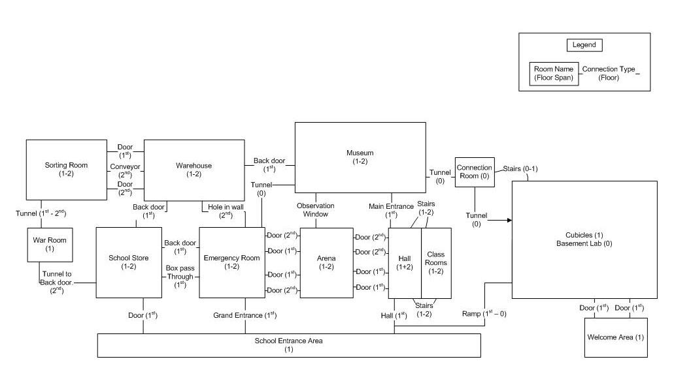

#### The Appendage Conservation Front Wing

##### Sorting Room

###### Environment

This room is open, airy, and has a cheerful tenor. It is lit through its myriad windows and is painted in natural colors. The floor is dirty, but not damaged or neglected. The walls are half natural material, half old stone from the fort. Vines and moss cover parts of it.

###### Conveyor Belt

* *Description:* Several belts at varying levels of inclination. Fairly worn down. Wide enough to support two players side by side. The belt has worn thin in places and been fixed up with cloth patches.
* *Quality:* Medium, 250/piece.
* *Use*: Proceed into and out of the sorting machine. Used as walkways.
* *Importance:* Gameplay (4). Art (3). Can be simplified in texture.

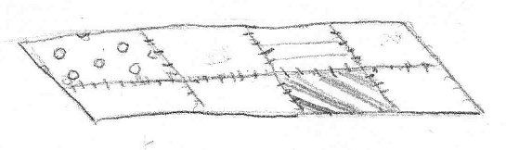

###### Wooden Body Part Boxes

* *Description:* Wooden boxes with depictions of appendages on them. At least one depiction for upper body and one for lower body.
* *Quality:* Low, 12-50.
* *Use*: Placed on conveyor belts and in stockpiles.
* *Importance*: Gameplay (3). Art (5). Cannot be simplified.

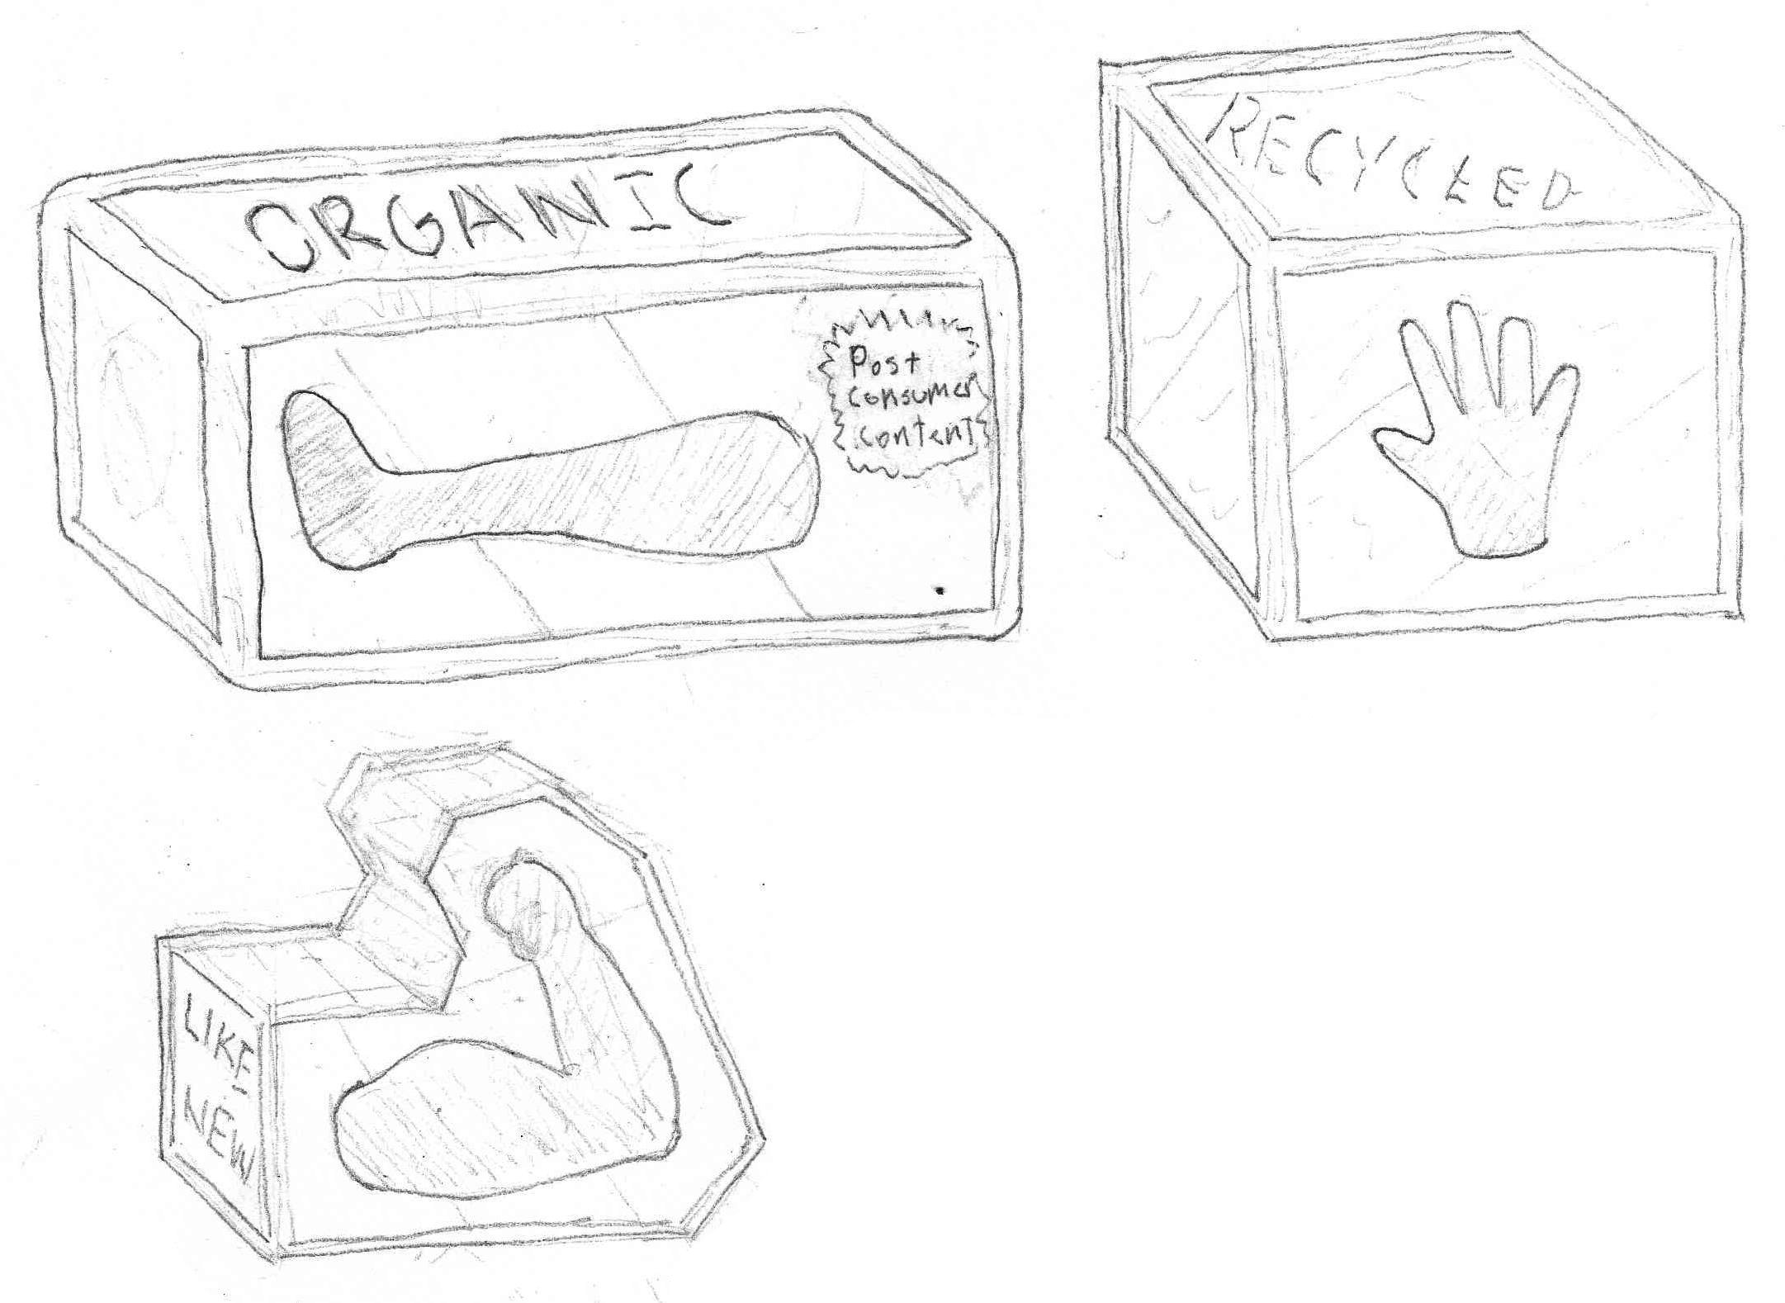

###### Delivery Truck Rear

* *Description:* The back of a delivery truck, partly open but not accessible. Decorated with the ACF logo.
* *Quality:* Low-Medium, 35-50.
* *Use*: Placed along the wall with only the rear two feet showing.
* *Importance*: Gameplay (1). Art (3). Can be simplified in complexity or texture.

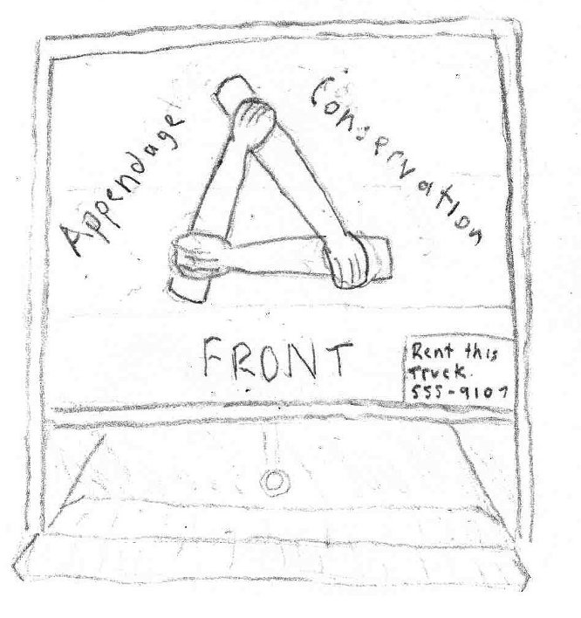

###### Categorization Signs

* *Description:* Two signs identifying the two categories that parts are sorted into: "Uppers" and "Lowers". Hand-painted.
* *Quality:* Low, 2-26/piece.
* *Use*: Placed above the conveyor exits from the *Sorting Room* into the *Warehouse*.
* *Importance*: Gameplay (1). Art (4). Can be simplified as long as body depictions are preserved.

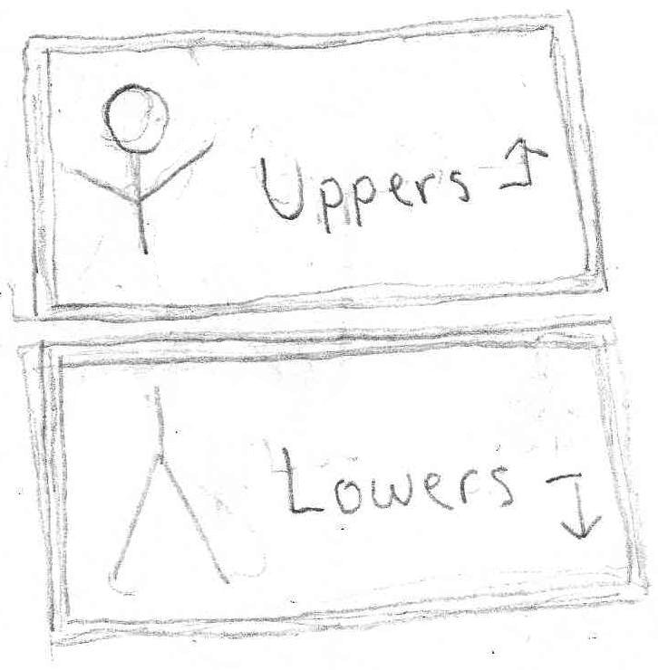

###### Windows

* *Description:* Large, greenhouse like window with multiple panes.
* *Quality:* Low, 2-18.
* *Use*: Allows light to enter through the backside and top of the sorting room.
* *Importance*: Gameplay (1). Art (3). Cannot be simplified.

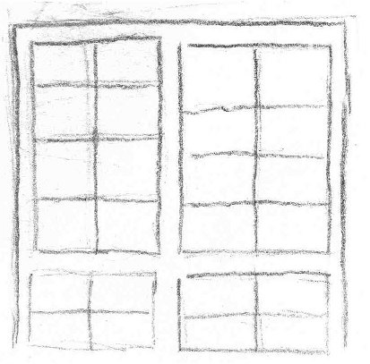

###### Flower Decorations "Diversi-pot"

* *Description:* Combination of several flower types on a single stem. Held in a small red pot. Should be scalable to two different heights (2' and 4').
* *Quality:* Medium, 800-1000.
* *Use*: Used to decorate and freshen the borders of the room.
* *Importance*: Gameplay (1). Art (3). Can be simplified as long as the stem holds at least two distinct flowers/fruits.

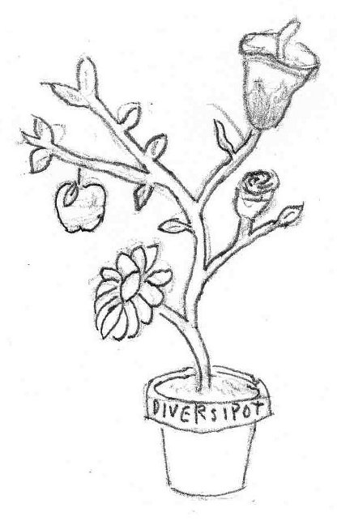

###### Sorting Machine

* *Description:* Large octagonal machine for sorting parts. Flat on the top with solar panels arranged around the outside like flowers petals. Various openings for conveyors to enter or exit. Decorated with environmental graffiti.
* *Quality:* Medium, 500-800.
* *Use*: Used as a platform on which to fight.
* *Importance*: Gameplay (5). Art (4). Textures can be simplified.

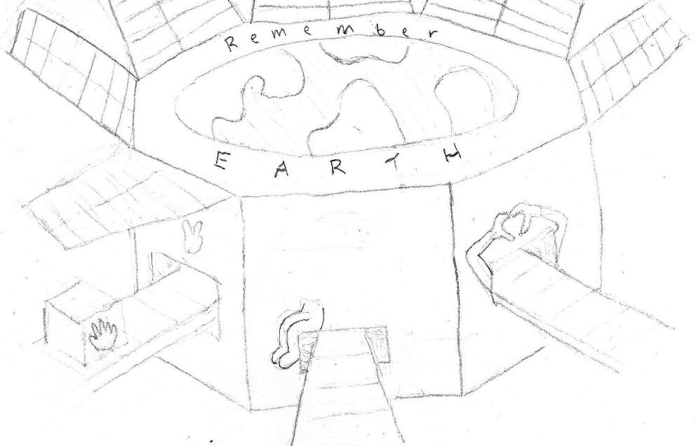

##### Warehouse

###### Environment

Large, cavernous, stone room that used to function as the armory. Worn down feeling. Some of the walls have moss on them.

###### Wooden Body Part Boxes

* *Defined In: "*Wooden Body Part Boxes" in *Appendage Conservation Front - Sorting Room*.

###### Categorization Signs

* *Description:* Signs labeling the various stock piles in the warehouse. Cardboard, hand painted. Size Labels: "Scrappy," "Solid." Types: "Hairy", "Goofy", "Magnificent," "Whoa"
* *Quality:* Low, 20-40/piece.
* *Use*: Placed above the stock piles, either hung or on a pole projecting from a pile.
* *Importance:* Gameplay (1). Art (4). Can be simplified a bit in texture.

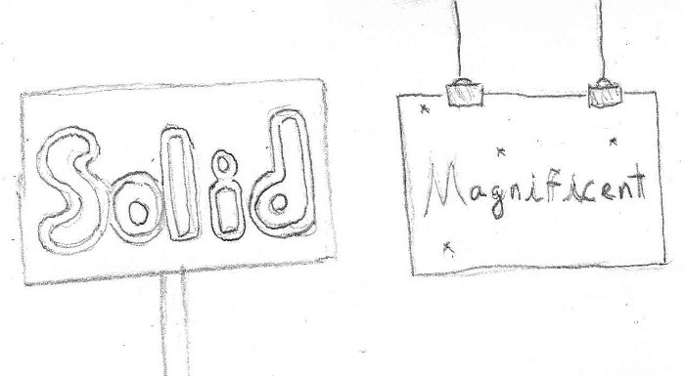

###### Armory Label

* *Description:* An official, solid looking military sign saying "ARMORY" with quotes around "ARM" (the joke being that it houses arms...). Yellow and black warning stripes on the sides.
* *Quality:* Low, 2-10.
* *Use*: Large scale and place on the longest wall of the room at a height to allow viewing from all parts of the room.
* *Importance*: Gameplay (1). Art (3). Cannot be simplified.

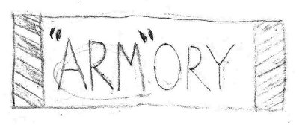

###### Warning Sign

* *Description:* A conspicuous sign warning of the dangers of discharging live ammunition in the Armory. Official, standardized look. Full of bullet holes and dents.
* *Quality:* Low, 2-10.
* *Use*: Placed around doors and stockpiles.
* *Importance*: Gameplay (1). Art (4). Cannot be simplified.

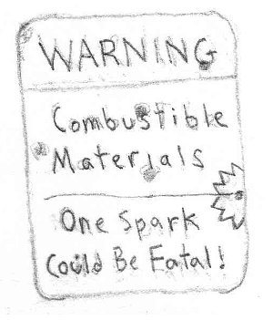

###### Gun Racks

* *Description:* Basic, functional racks that can hold a number of weapons upright. Overflowing with both boxes and weapons.
* *Quality:* Low, 60 w/o objects.
* *Use*: Allow players to run along top. Placed in series across the room.
* *Importance:* Gameplay (5). Art (3). Can be simplified to unadorned warehouse pallet racks.

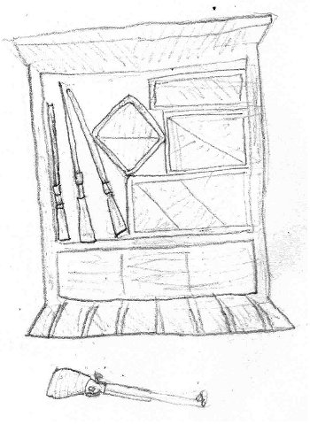

###### Part Piles

* *Description:* Messy collections of part boxes labeled with signs.
* *Quality:* Medium, 100-200.
* *Use*: Placed on the floor around the room.
* *Importance*: Gameplay (4). Art (4). Cannot be simplified.

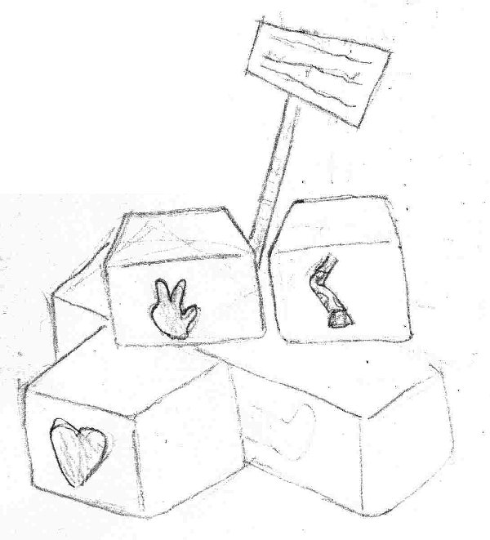

##### War Room

###### Environment

Octagonal shape. Wood paneled walls. Tile floor. Has a dim, smoky feel.

###### War Table

* *Description:* An octagonal table covered with paperwork, a cigarette tray, a bottle of soy-milk, and scotch glasses.
* *Quality:* Medium, 200-300.
* *Use*: Placed in the middle of the war room.
* *Importance*: Gameplay (3). Art (4). The items on top of the table can be simplified or removed.

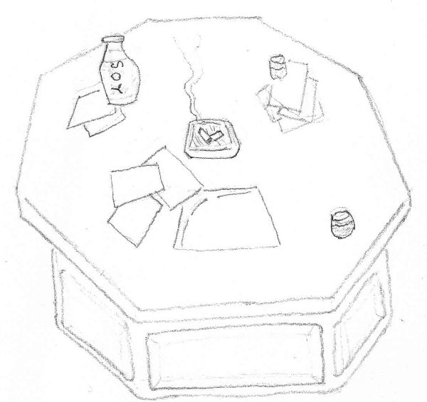

###### Battlefield Map

* *Description:* A gridded map depicting an upcoming operation. The map shows the target ("Home & Clone"), their shipping network, the plan to swap packages to mismatch gift deliveries, and the result (a large muscular guy now with tiny forearms).
* *Quality:* Medium-High, 150.
* *Use*: Hung prominently on one wall.
* *Importance*: Gameplay (1). Art (4). The map details can be simplified to a single target.

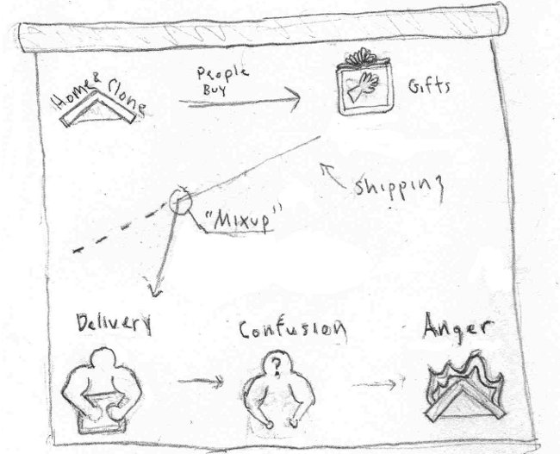

###### Wanted Posters

* *Description:* Various posters advertising ACF services: support group for clones, and a recruitment poster for their vintage fashion line.
* *Quality:* Low, 2-10.
* *Use*: Placed around the room.
* *Importance*: Gameplay (1). Art (3). Cannot be simplified.

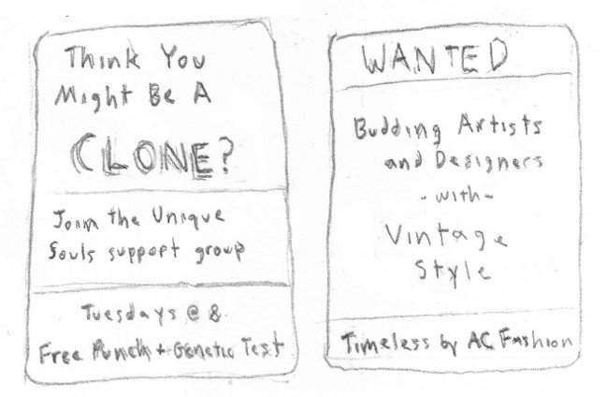

##### School Store

###### Environment

Carpeted floors. Walls painted green on the bottom half. Parts of the walls are covered with banners for the school. It is split into two vertical levels, with the left side of the store raised higher than the right. The left side has school supplies while the right has parts.

###### Bargain Bin

* *Description:* An 8' x 8', low-sitting bin with parts boxes piled in it. This bin connects through a chute horizontally to the emergency room.
* *Quality:* Medium, 200-300.
* *Use*: Placed near the center of the store.
* *Importance*: Gameplay (4). Art (4). Cannot be simplified.

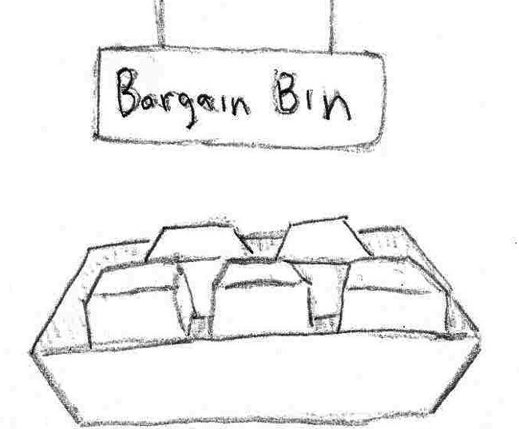

###### Reclaimed Crafting Supplies Bins

* *Description:* Bins containing recycled materials including: gun powder, radioactive waste, wood, and assorted chemicals.
* *Quality:* Low, 200-300.
* *Use*: Placed near the entrance to the store (interspersed with school supplies).
* *Importance:* Gamplay (2). Art (3). Can remove some of the supplies types.

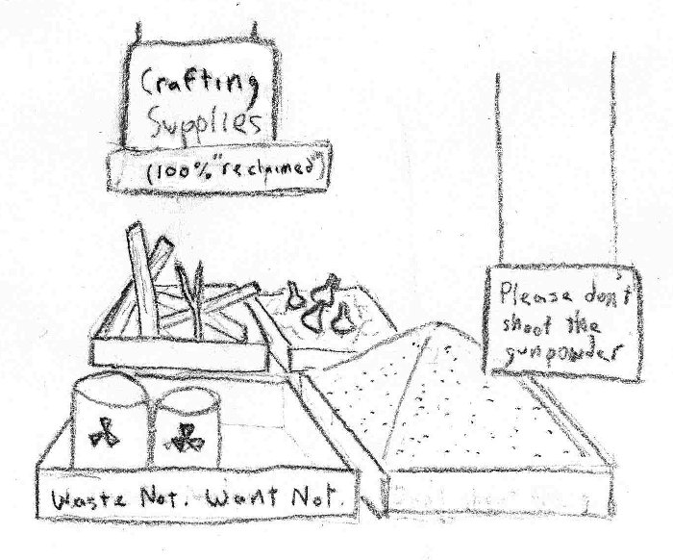

###### Register

* *Description:* Registers for selling the various supplies at the store. Marked with signs advertising for trade-ins.
* *Quality:* Low, 50.
* *Use*: Placed near the entrance to the store.
* *Importance*: Gameplay (1). Art (3). Details can be simplified.

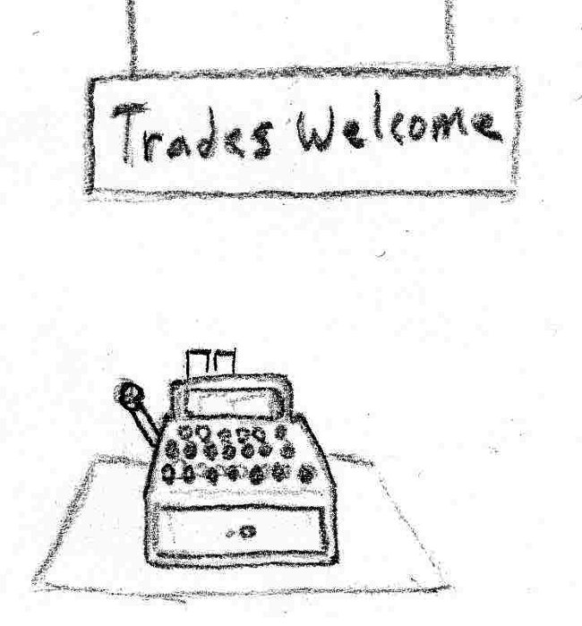

###### Categorization Signs

* *Description:* Signs labeling the different part types being sold. Roles include: Strong arms for holding weapons, Heat resistant arms for crafting, glowing appendages for drawing attention, and Camouflaged parts for blending in.
* *Quality:* Low, 2-10.
* *Use*: Placed above the mannequin displays below.
* *Importance:* Gameplay (1). Art (3). Cannot be simplified.

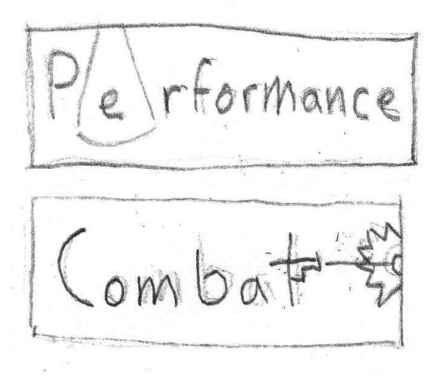

###### Mannequin Displays

* *Description:* Mannequins on platforms showing off the looks specified in "Categorization Signs."
* *Quality:* Medium.
* *Use*: Spread about the room.
* *Importance:* Gameplay (3). Art (4). Can reduce the number of displays or the scene complexity.

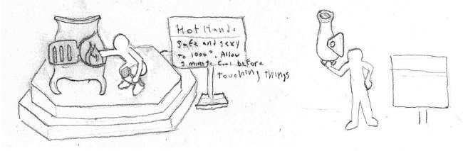

###### Clothing Racks

* *Description:* Generic clothing racks holding shirts of various sizes. New clothes to fit the shape and style of your new parts.
* *Quality:* Medium, 250-300 w/o items.
* *Use*: Used to segment the room. Placed around the exterior.
* *Importance:* Gameplay (4). Art (3). Cannot be simplified.

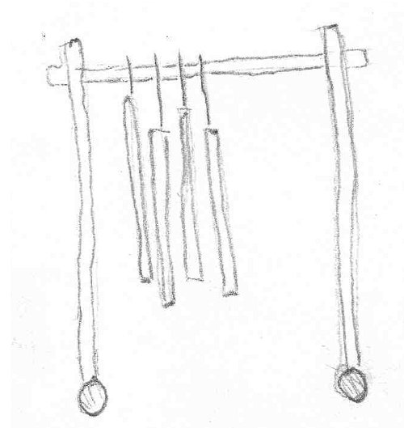

###### Dressing Room Door Facings

* *Description:* Doors that are decorated and numbered like dressing room doors, with additional machinery around the periphery to indicate the technological process of switching parts.
* *Quality:* Medium, 400-500.
* *Use*: Placed in a row against one wall.
* *Importance*: Gameplay (1). Art (4). The ornamentation of the facing can reduced.

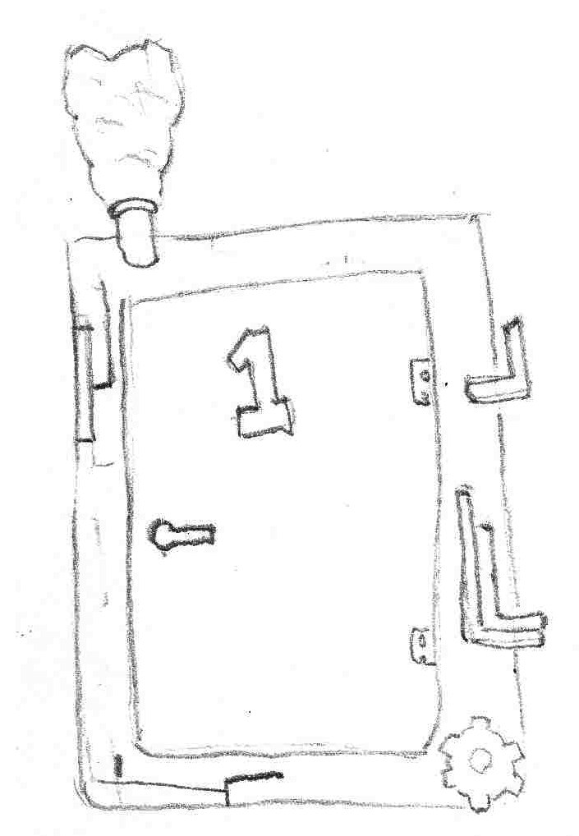

##### Emergency Room

###### Environment

Hospital white floors. Well lit. Sectioned off by curtains. Light green highlights on the walls.

###### Gurney

* *Description:* A standard, while hospital gurney.
* *Quality:* Medium, 400-500.
* *Use*: Placed by the entrance doorway.
* *Importance*: Gameplay (2). Art (4). Cannot be simplified.

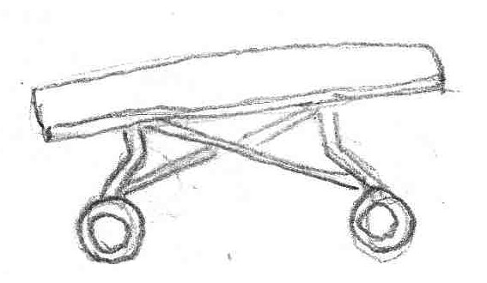

###### Marked Down Parts Boxes

* *Description:* A parts box covered with orange stickers that announce its low price or damage goods.
* *Quality:* Medium, 400-500.
* *Use*: Placed in the hopper holding boxes that came from the school store bargain bin.
* *Uses Content From:* Parts Boxes - *Appendage Conservation Front Wing - Sorting Room*
* *Importance:* Gameplay (3). Art (4). Cannot be simplified.

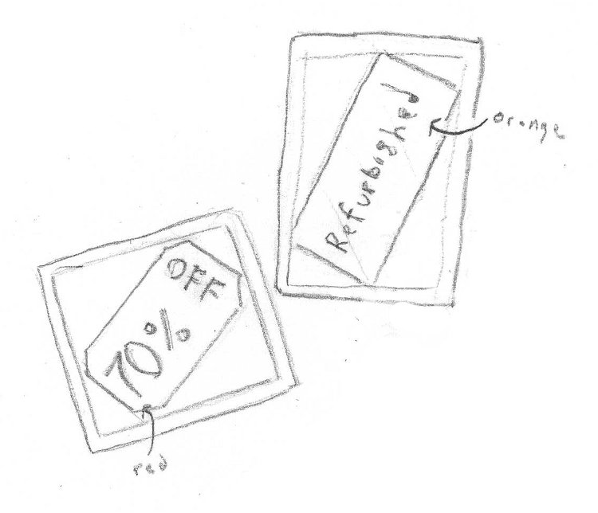

###### Curtains

* *Description:* Light blue curtains hung from rolling metal racks.
* *Quality:* Medium
* *Use*: Breaks the emergency room into different areas of specialty.
* *Importance:* Gameplay (4). Art (4). Cannot be simplified.

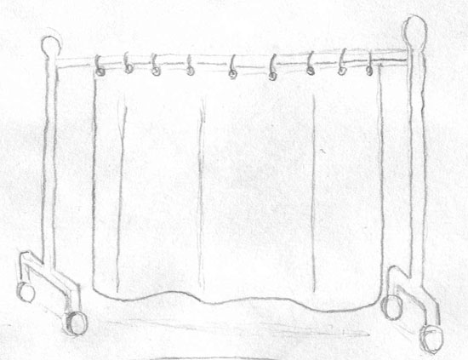

###### Ward Signs

* *Description:* Signs marking the different specialty areas in the emergency room.
* *Quality:* Medium
* *Use*: Placed on the walls and curtains of the different areas.
* *Importance*: Gameplay (1). Art (4). Number of wards can be reduced.

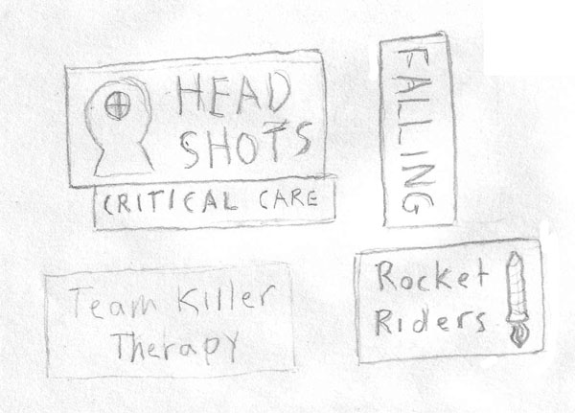

###### Respawners

* *Description:* Specialized machinery for quickly repairing FPS victims ("Out in 5 seconds or less"). Shaped to represent the different injuries. A respawn timer is placed on the outside of the door.
* *Quality:* High.
* *Use*: Placed around the room within the curtains. They lay on the floor in the same orientation as an operating table.
* *Importance*: Gameplay (2). Art (4). Number of types can be reduced.

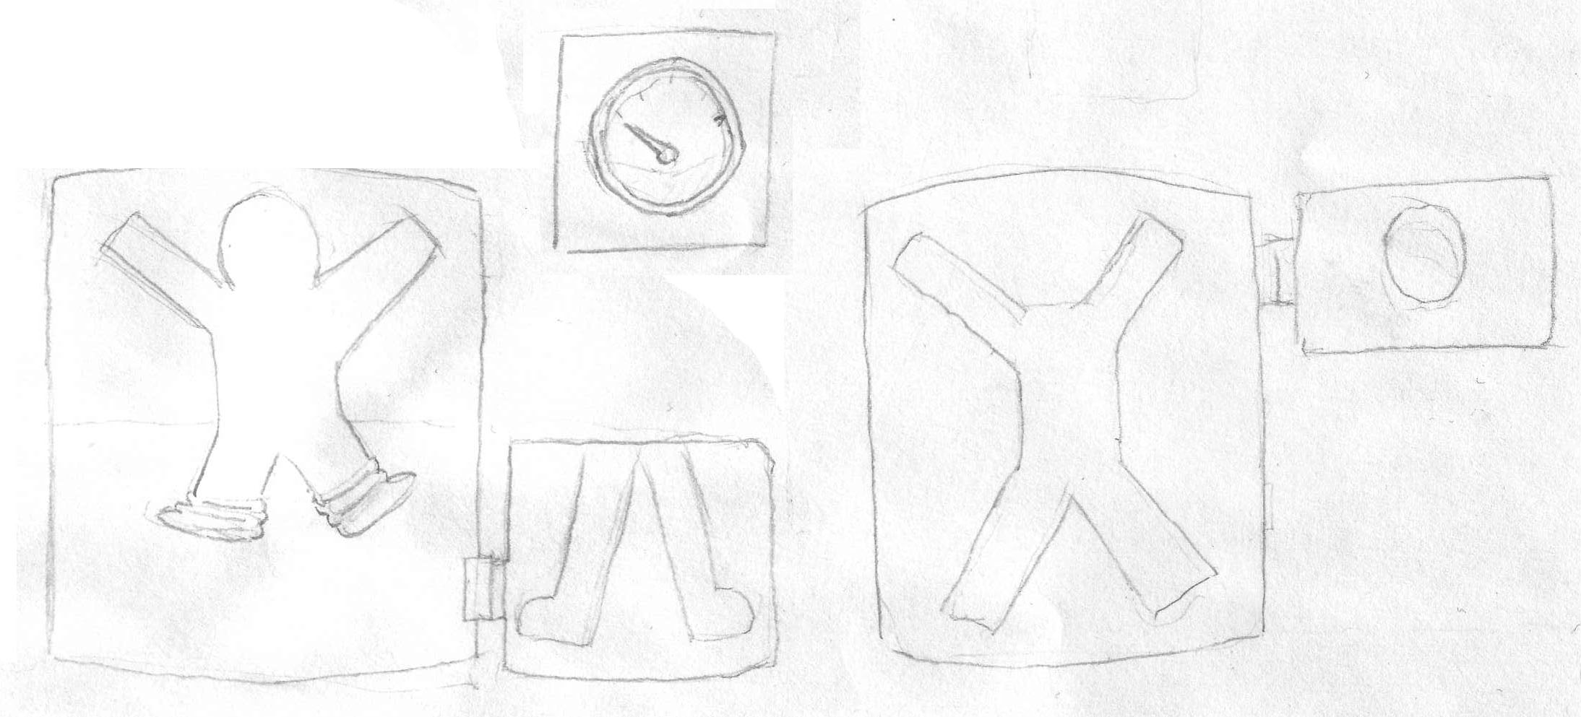

#### Academy Wing

##### The Higher Learning Arena

###### Environment

The floor in this room is covered in colorful, rubberized material that is high traction and easy to clean. The walls are constructed from stone with pads on their bottom sections. Various educational areas are arranged around it, including a target for practicing the knock back modifier and decoys. It has a variety of layouts emphasizing the different situations on an FPS (cover, high ground, spawn camping, etc).

###### Learning Opportunity Decals

* *Description:* Colorful decals that identify locations. Meant to teach students about combat. Examples include: "Spawn Camping Area, Sniper Spot, Run Away, Spawn Area, Taunt, Photo Op"
* *Quality:* Low, 2-50/piece.
* *Use*: Placed on the floors and walls around the arena.
* *Importance*: Gameplay (1). Art (5). Can be simplified in number and ornateness.

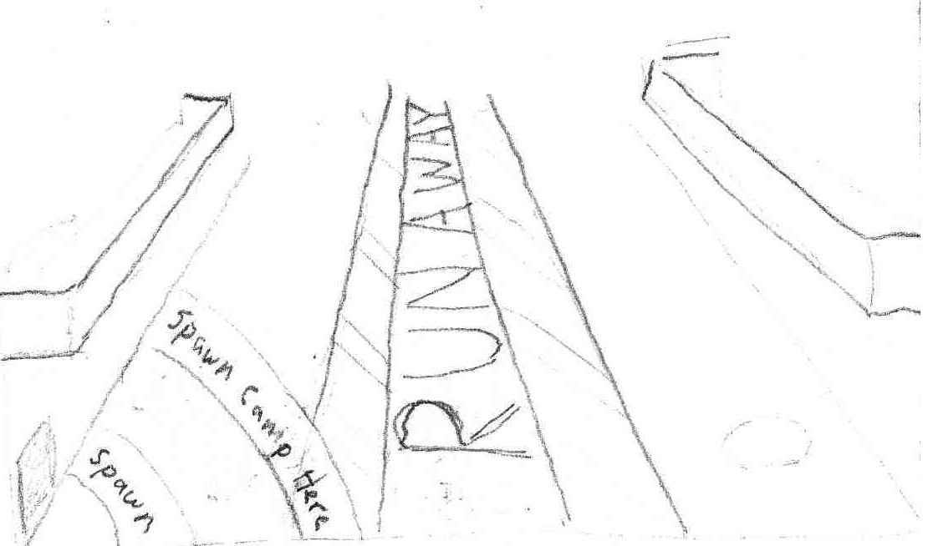

###### Grade Scoreboard

* *Description:* Wall mounted scoreboard depicting ranks for each student along with kill:death ratio and number of trap triggers. Bell mounted on the top rings every 30s and then scoreboard announces "N-n-new Valedictorian" if there is a new leader.
* *Quality:* Low, 130.
* *Use*: Placed on a non-covered wall at a height to place between the 1st and 2nd level.
* *Importance*: Gameplay (2). Art (5). Can be stripped of functionality.

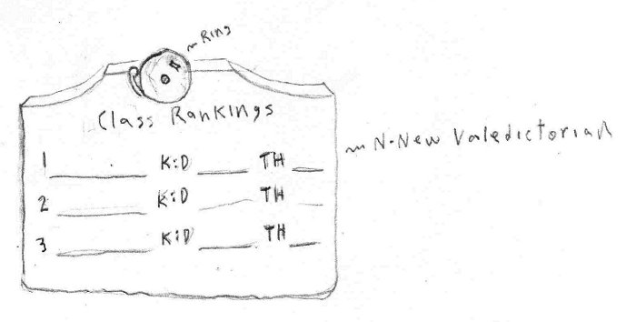

###### Cat Walks

* *Description:* Metal cat walks of about 8 feet in width. Secured to the wall on the bottom with bolted L-shaped pieces of metal. Colored dark grey.
* *Quality:* Medium, 400/piece.
* *Use*: Attached to the walls and between other cat walks. Two floors vertical.
* *Importance*: Gameplay (5). Art (3). Can play with the railing details.

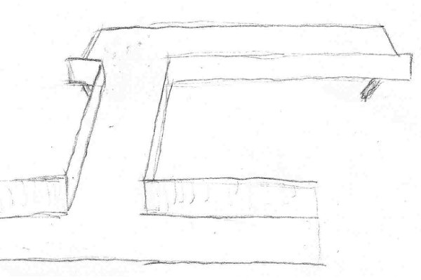

##### The Classrooms

###### Environment

Stone walls and floors. Items are colored blue or red based on which team the student is a part of. Some parts of the classroom are mock battlefield environments. There are six total, stacked with three per floor on two floors.

###### Chalkboard

* *Description:* Chalkboards depicting the name of the subject taught in the classroom. Roughly 4' x 12'. Classes include:
  + Team Combat: Defense
  + Team Combat: Offense
  + The Importance of High Ground
  + Spawn Camping: Do's and Don't's
  + Our Violent History of Warfare: Tips and Tricks
  + Don't Shoot the Camera: Combat as Performance Entertainment
* *Quality:* Low, 70.
* *Use*: Attached to one classroom wall.
* *Importance:* Gameplay (1). Art (5). Number of classrooms can be reduced.

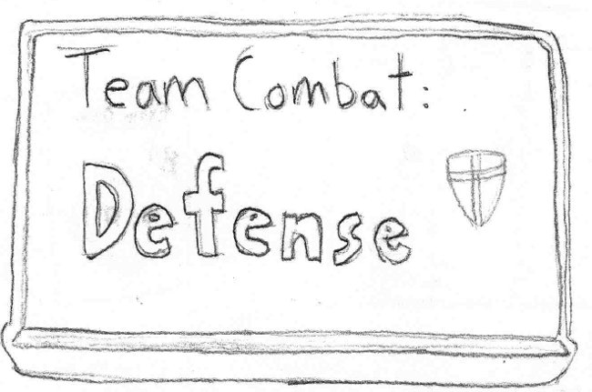

###### Chairs

* *Description:* Standard mass produced seating. Folding wooden chairs.
* *Quality:* Medium, 150.
* *Use*: Placed around the edges of the classroom.
* *Importance:* Gameplay (2). Art (3). Folding mechanism can be simplified.

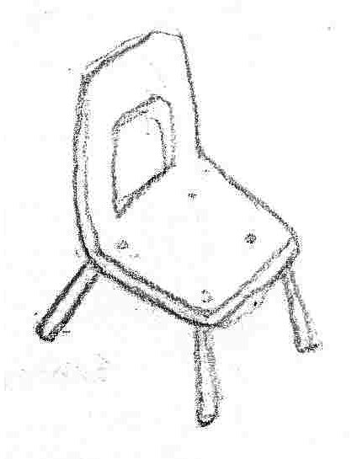

###### Rubble

* *Description:* Small and medium sized rocks clustered around the holes that were punched in the class room walls.
* *Quality:* Low, 50/piece.
* *Use*: Placed around the edges of the classroom.
* *Importance*: Gameplay (1). Art (3). Number of different types of rocks can be reduced.

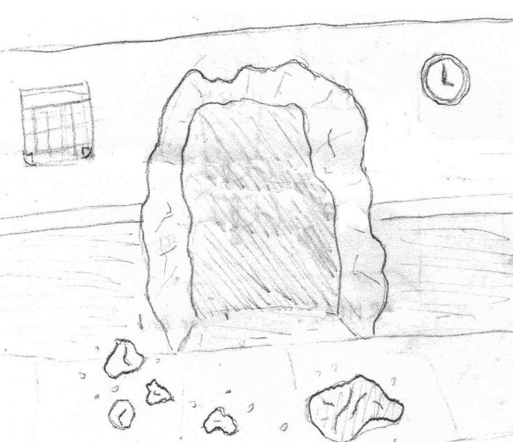

###### Sandbag Wall

* *Description:* Sandbags stacked in a wall to provide protection against bullets. Tall enough to block the bottom 2/3 of a person and wide enough to cover a small tunnel in width.
* *Quality:* Low-Medium, 50/piece.
* *Use*: Placed blocking the exit from the tunnel connecting the Team Combat: Offense class to the Team Combat: Defense class.
* *Importance*: Gameplay (4). Art (4). Cannot be simplified.

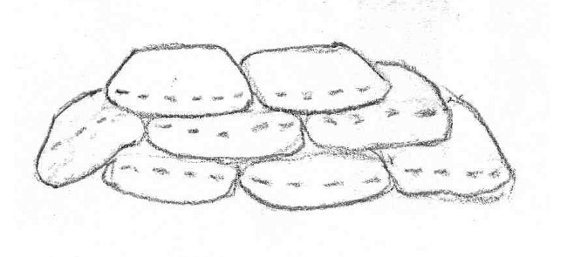

##### The Classroom Hallway

###### Environment

Brick halls with tile floors. Posters and lockers line the walls.

###### Lockers

* *Description:* Gun-metal gray lockers with combination locks. Six to a bank. 5' tall.
* *Quality:* Low, 40.
* *Use*: Placed on one side of the hallway to act as cover.
* *Importance:* Gameplay (4). Art (4). Cannot be simplified.

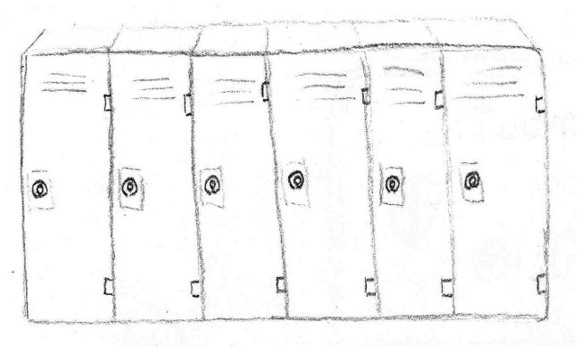

###### Graded Shooting Targets

* *Description:* Black and white, cartoonish shooting target graded with a B+.
* *Quality:* Low, 2-10.
* *Use*: Posted on a locker.
* *Importance:* Gameplay (1). Art (3). Cannot be simplified.

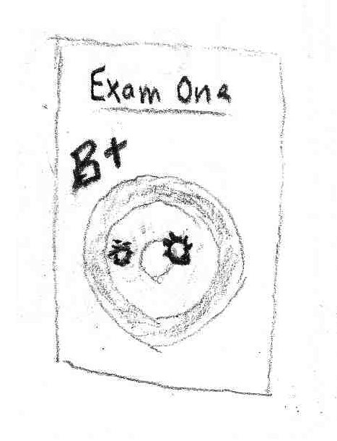

###### School Dance Poster

* *Description:* Poster advertising for the School Dance: "Red meets Blue: Senior Prom"
* *Quality:* Low, 2-10.
* *Use*: Placed in between the lockers.
* *Importance:* Gameplay (1). Art (3). Cannot be simplified.

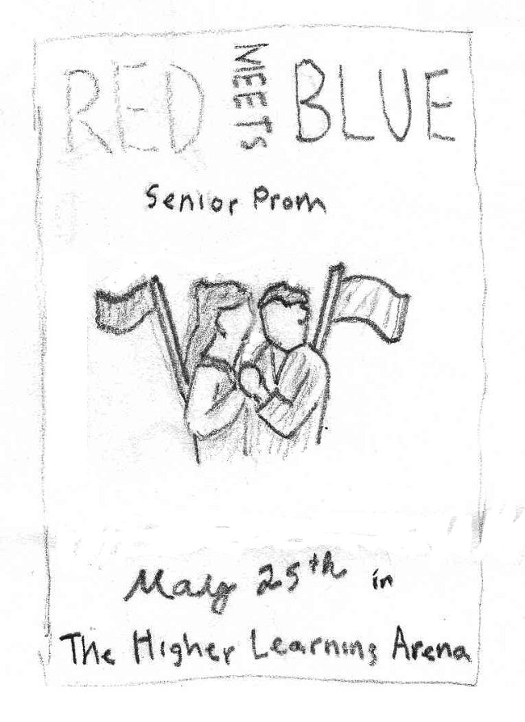

#### The Society for Historical Beatdowns Wing

**[Note: This wing can optionally be closed off to reduce the size of the map / asset creation. Hidden / optional assets are labeled as (Optional) in their title.]**

##### The Museum

###### Environment

This large hall typifies the personalities of the professors. It is a worn and crumbling edifice that has been patched over to give the impression of grandeur. Holes in the walls have been covered over. The architectural style is classical, and focuses on whites, reds, and golds.

###### Classical Greek Airlock

* *Description:* An ancient Greek style entrance. A doorway, flanked by two columns, with a triangular upper piece. The doorway itself is composed of two sliding stone doors that are pressurized as an airlock. Labeled with "AIRLOCK" (it was "restored," filling in where four missing letters were). The air lock explains some unusually well preserved artifacts.
* *Quality:* Medium, 300.
* *Use*: Functions as a sealed entrance to the museum if it is to be closed.
* *Importance*: Gameplay (2). Art (4). Cannot be simplified.

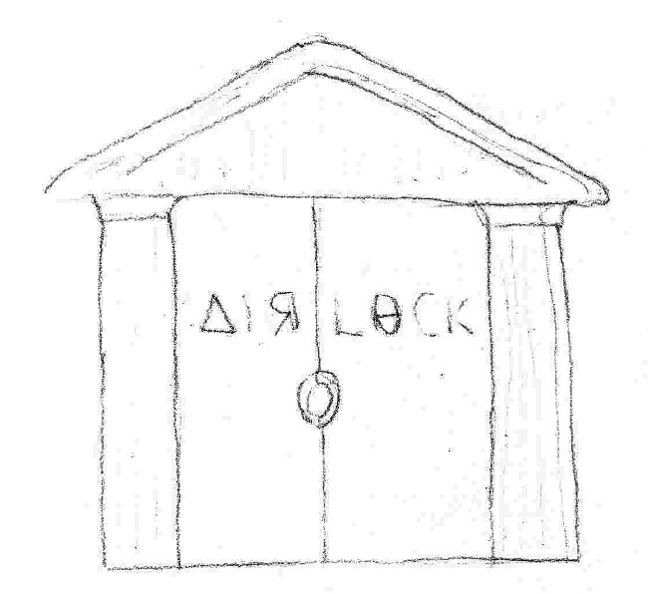

###### Exhibit Posters

* *Description:* Posters showing off the various exhibits inside the museum. One for each of the exhibits listed below: The Cannon, The Bowmerang, and The Gods of the Past.
* *Quality:* Low, 2-10.
* *Use*: Hung on the walls and doors around the museum.
* *Importance*: Gameplay (1). Art (4). Detail in the poster drawings can be reduced.

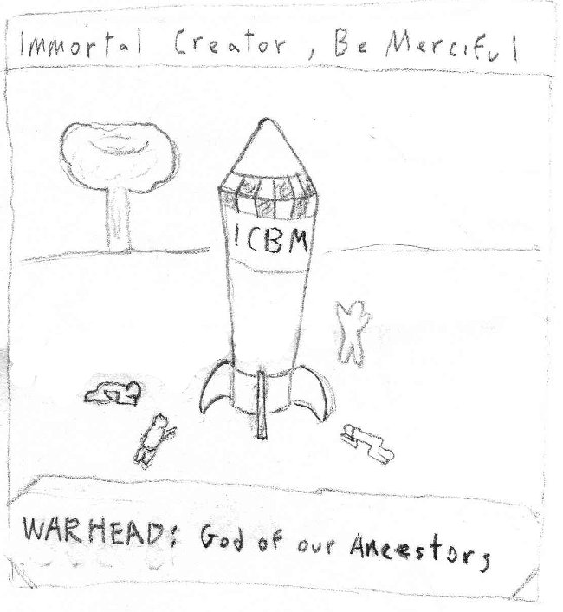

###### Cannon-wielding Exo-Skeleton (Optional)

* *Description:* A large, iron and wooden exo-skeleton. Dating back to the Civil War. Wields a cannon on one arm and a ramrod on the other. A misconception of how cannons are used.
* *Quality:* Medium, 2000-3000.
* *Use*: Placed in the museum.
* *Importance*: Gameplay (4). Art (4). Can be simplified, but must be its component parts must be recognizable (Civil War and the cannon).

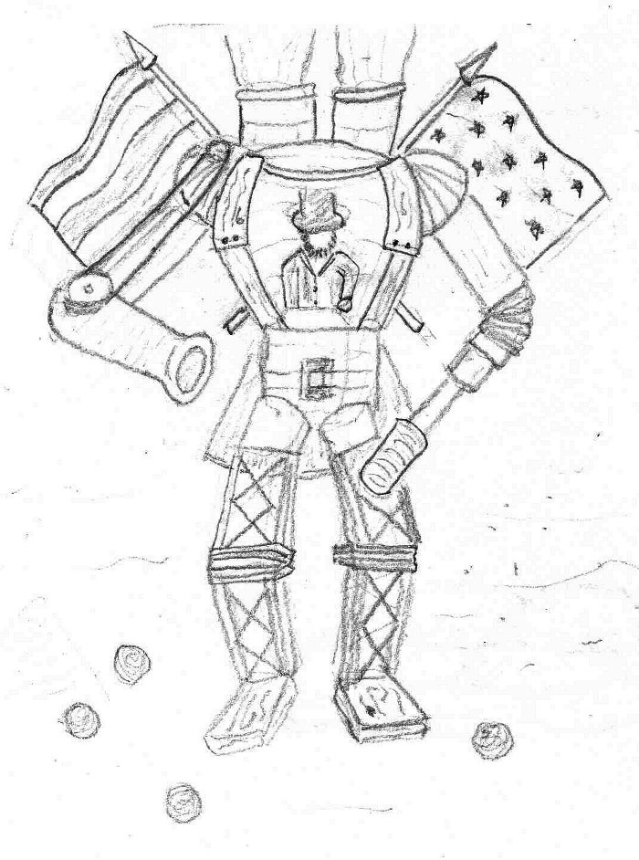

###### Bowmerang Diorama (Optional)

* *Description:* A life-size diorama cordoned off by velvet rope. Depicts two men: the first is drawing back the bowmerang to shoot it, and the second is the soon to be victim. In between, semi-transparent bowmerangs are hung to depict the flight path. The bowmerang is a bow shaped piece of wood with its draw string covered in glass and spikes.
* *Quality:* Medium, 100 for bow + character.
* *Use*: Placed in the museum.
* *Importance*: Gameplay (3). Art (4). The mannequins can be simplified.

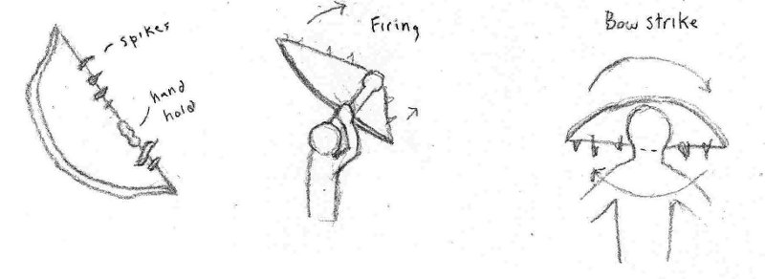

###### ICBM Diorama (Optional)

* *Description:* A larger-than-life ICBM surrounded by people worshipping/groveling. The ICBM is labeled with ICBM and Warhead. The backdrop shows a mushroom cloud.
* *Quality:* Medium.
* *Use*: Placed in the museum.
* *Importance*: Gameplay (4). Art (4). The number of worshippers can be reduced.

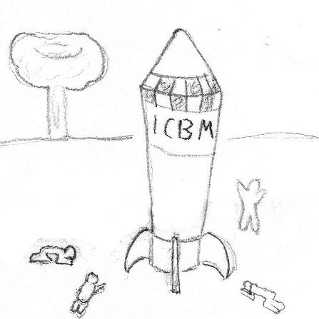

###### Drapery (Optional)

* *Description:* Drapery hung on the windows of the museum. It is made from a rich material like velvet or silk. The windows are small and almost prison-like, which is typical for a fort.
* *Quality:* Medium.
* *Use*: Hung on the windows around the museum. Cover defects and holes in the walls.
* *Importance*: Gameplay (1). Art (4). The draping of the fabric can be reduced to flatness.

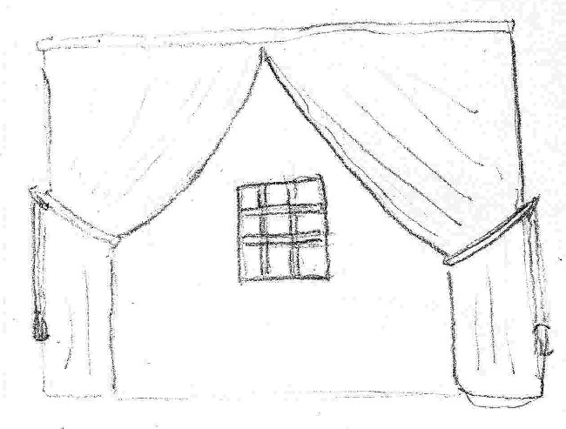

###### Columns (Optional)

* *Description:* Plaster, Corinthian columns erected around the stone supports of the original fort. They only stretch up 2/3 of the original supports.
* *Quality:* Medium, 700/piece.
* *Use*: Supporting the ceiling.
* *Importance:* Gameplay (5). Art (4). Fluting detail can be reduced.

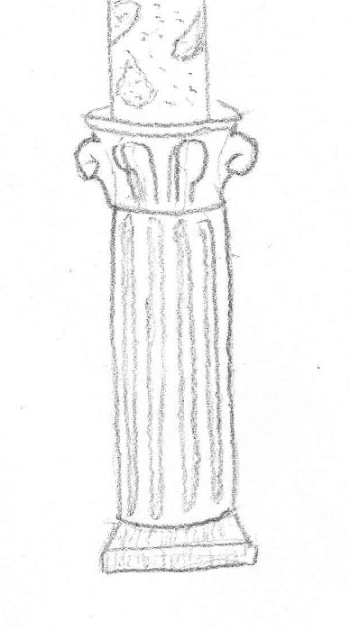

#### Impossible Possibilities Wing

##### Ground Level – Cubicles

###### Environment

A tidy corporate environment. Well kept, well lit, and bland. Features fancy metallic "sculpture" hung on the windowed ceiling.

###### Impossible Possibilities Sign

* *Description:* Futuristic looking sign displaying the Impossible Possibilities logo. It is holographic and floating in the air behind the welcome desk.
* *Quality:* Medium, 700.
* *Use*: Floating behind the welcome desk. Meant to be impressive.
* *Importance*: Gameplay (2). Art (4). Holographic effect can be reduced to a normal sign constructed of stainless steel.

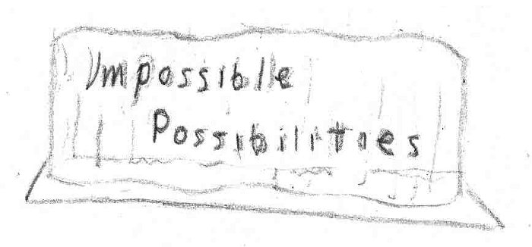

###### Welcome Desk

* *Description:* Made from glass. Wide but not bulky. Hovers above the ground.
* *Quality:* Low-Medium, 200.
* *Use*: Placed facing the entrance to this wing.
* *Importance*: Gameplay (3). Art (3). Can be simplified in shape.

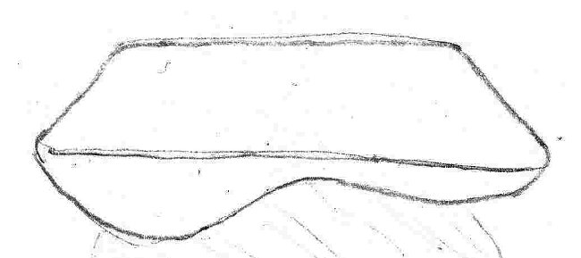

###### Cubicle

* *Description:* Six foot by six foot cell. Contains desk and chair. All four walls are information displays showing busy work (support calls, paperwork). Hacked to display impossibly good values.
* *Quality:* Medium, 200/piece.
* *Use*: Cover most of the upper level.
* *Importance*: Gameplay (5). Art (3). Textures can be simplified.

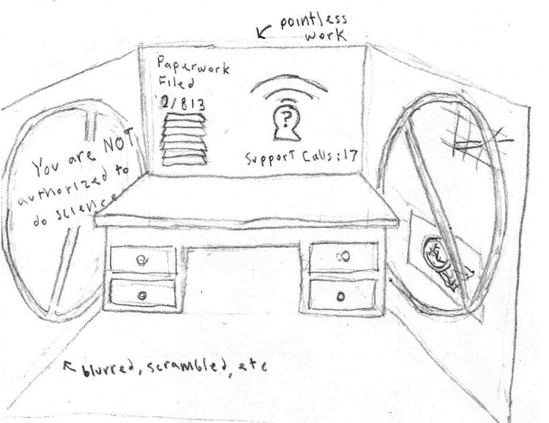

###### We Trust Our Employees Sign

* *Description:* A large corporate sign with the words "We Trust Our Employees." Set into the letters are microphones and video cameras.
* *Quality:* Low, 40-50.
* *Use*: Placed along one wall, facing all of the cubicle entrances.
* *Importance*: Gameplay (1). Art (4). Number of devices in the letters can be reduced.

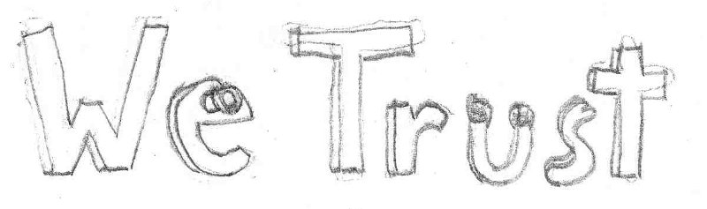

###### Mannequin

* *Description:* Crude mannequins stolen from the ACF store and dressed in lab coats.
* *Quality:* Medium.
* *Use*: Placed in various cubicles to create the illusion of work.
* *Importance*: Gameplay (1). Art (3). Cannot be simplified.

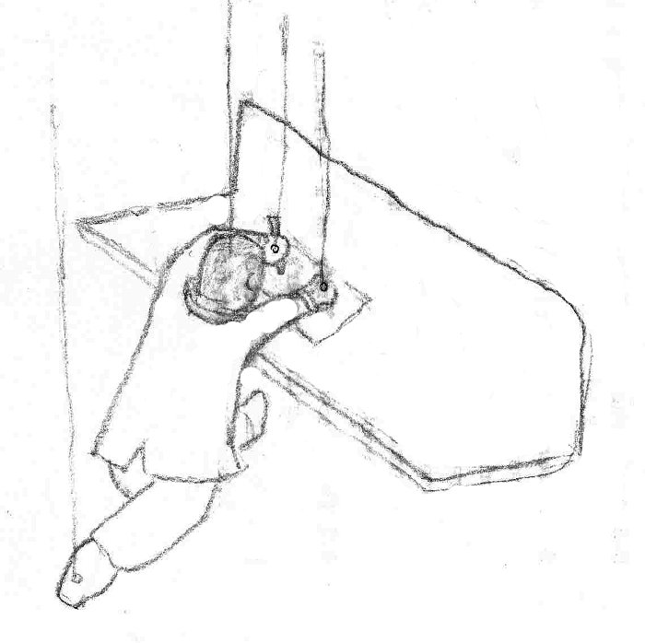

##### Basement Level – Lab

###### Environment

A large, subterranean area that is catacomb-like. Its walls are charred and deformed by explosions. In some places, the outlines of test subjects can be seen. It has two entrances: one from above in the office space area and one from a hall exiting the Academy wing. There are still various skeleton and torture devices around.

###### Suits Warning Sign

* *Description:* A white neon sign saying "Impossible Possibilities." The "Possibilities" part is burnt out. It displays "Possible" most of the time, but switches over to "Impossible" when the suits arrive. Flanked by red lights that also flash when the suits come by.
* *Quality:* Low, 2-10.
* *Use*: Placed in a high visibility spot to provide ample warning.
* *Importance:* Gameplay (1). Art (4). Functionality can be removed.

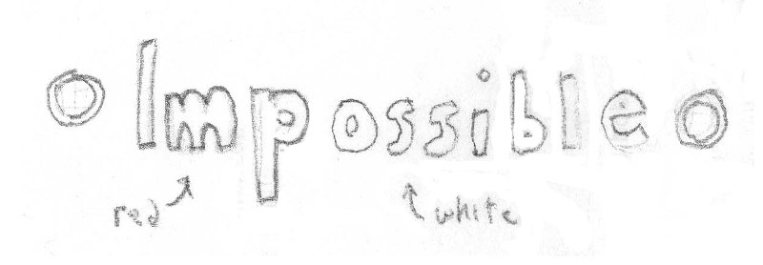

###### Entrance Warning Light and Sign

* *Description:* A red light embedded in a sign saying "Warning: Somebody is coming." The light activates whenever a player is standing in any of the inbound hallways.
* *Quality:* Low, 40.
* *Use*: Placed near the entrances to the Basement level.
* *Importance*: Gameplay (3). Art (3). Cannot be simplified.

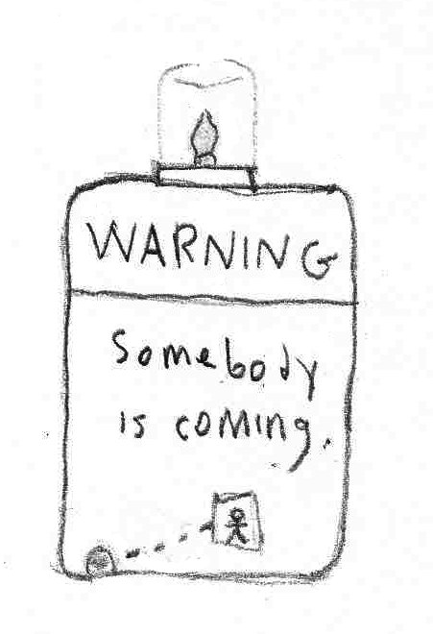

###### Experimental Apparatuses

* *Description:* Modifiers that are being tested and devices for testing them. They apply their effects to the immediate area around them. When the suits alarm goes off, they fold up into the wall.
* *Quality:* Medium.
* *Use*: Placed around the room.
* *Importance:* Gameplay (3). Art (4). Can be reduced in number and complexity.

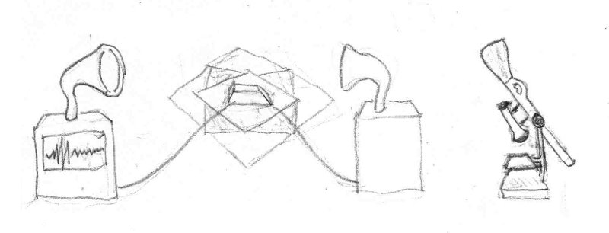

###### Test Subjects

* *Description:* Various living and non-living objects that are used to test the modifiers. Examples are: Cows and Mannequins.
* *Quality:* Medium.
* *Use*: Placed in the experimental areas.
* *Importance:* Gameplay (2). Art (3). Can be replaced with simpler test subjects.

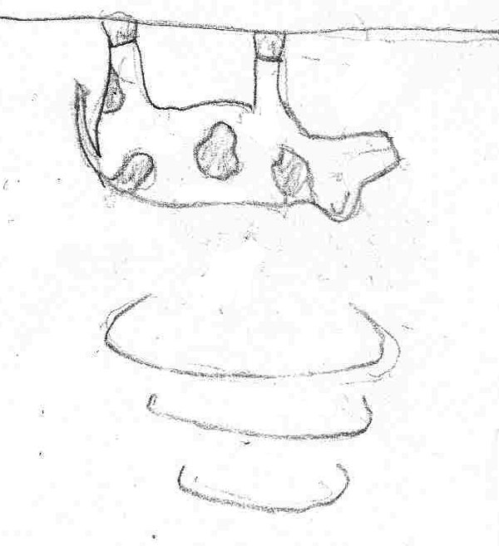

###### Inverted Cubicle

* *Description:* A cubicle environment attached upside-down to the ceiling. It is placed in a gravity inversion area to test the effects of the modifier.
* *Quality:* Medium, 200/piece.
* *Use*: Placed in the room on the ceiling.
* *Uses Content From*: **Ground Level – Cubicles** “Cubicle.”
* *Importance:* Gameplay (4). Art (4). Cannot be simplified.

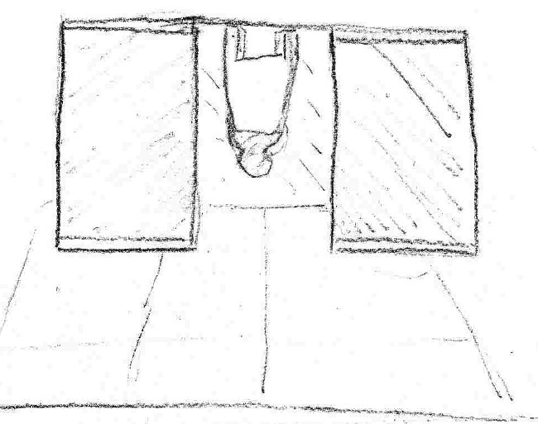

###### Hide-able Lab Bench

* *Description:* A laboratory bench with various electronic parts placed on its service. A curved back chair by it with a scientist sitting on it. Folds up into the wall.
* *Quality:* Medium, 100.
* *Use*: Placed along one wall, facing all of the cubicle entrances.
* *Importance*: Gameplay (4). Art (3). Ornaments on bench surface can be removed.

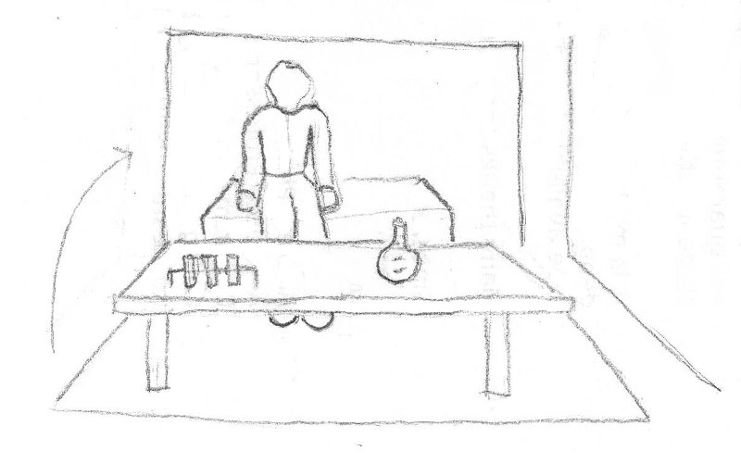

# Animations

## Character Animations

### Walk

**Action:** A medium speed jogging motion. As each foot prepares to strike the ground, the other foot has already left it.

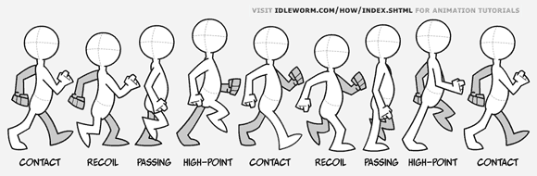

### Die

**Action:** The player collapses to the ground with arms splayed out and knees bent.

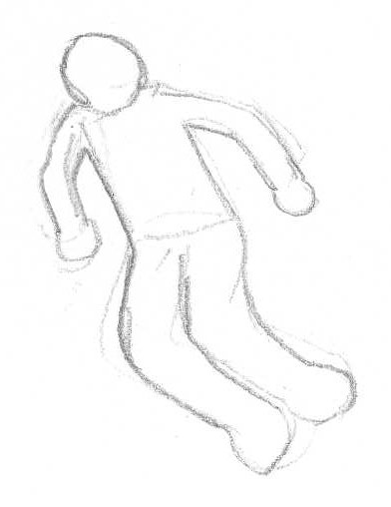

### Jump

**Action:** The player jumps upwards bending the knees and raising the upper legs.

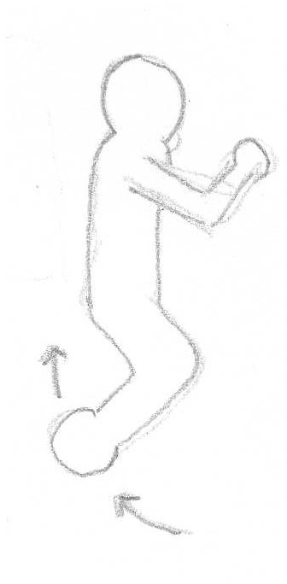

### Fall

**Action:** The player model extends the legs and moves them in small circles.

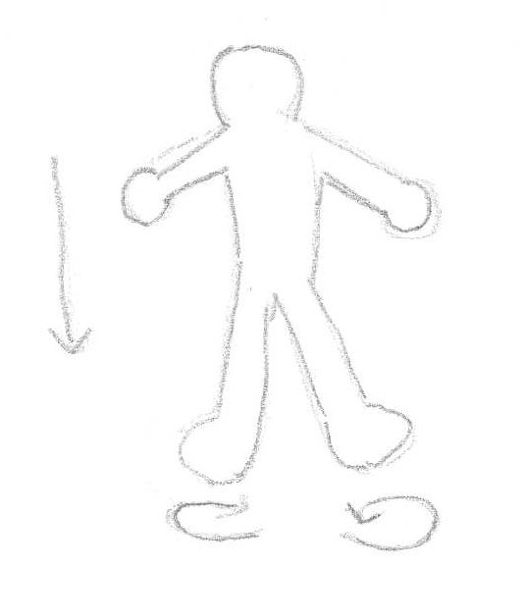

### Invert

**Action:** The player begins moving in the opposite direction of the current gravity vector while the model rotates 180 degrees about the X and Y axes.

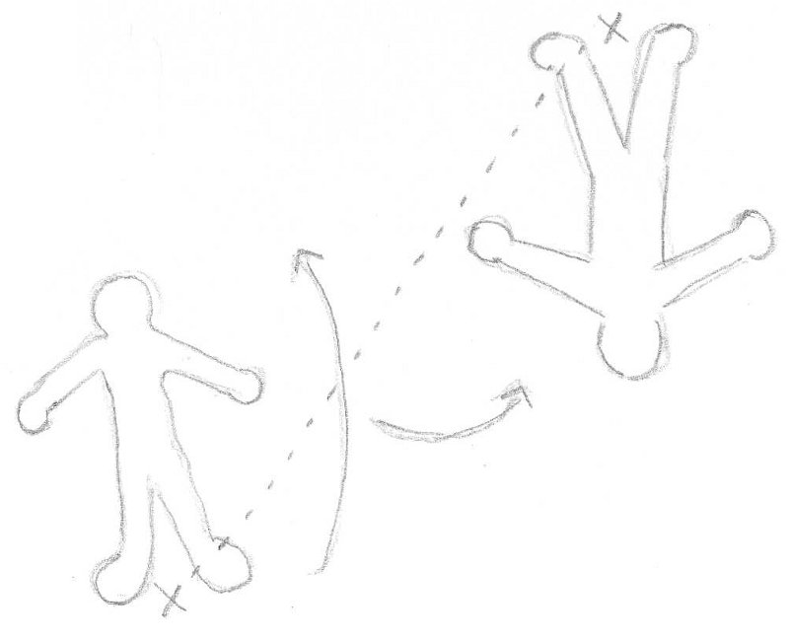

### Grow

**Action:** Scales the player model up and slows the walk cycle animation.

### Shrink

**Action:** Scales the player model down and speeds up the walk cycle animation.

## Weapon Animations

### Modifier Launcher

* **Hold:** Two-handed. Clutches the box on both sides.
* **Deploy:** Holds the box on the right, reaches in with the left, grabs a modifier and flings it by straightening the arm.
* **Take out/Replace:** Reaches over the shoulders towards the back with both hands.

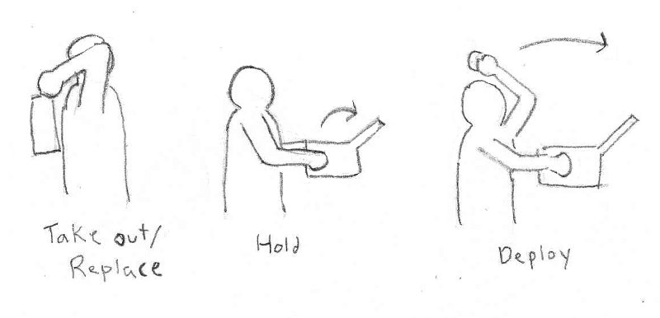

### Nullifier Weapon

* **Hold:** One-handed. Hand grips the remote shape from the side.
* **Deploy:** Presses the button on the surface with the holding hand.
* **Take out/Replace:** Reaches down toward the legs.

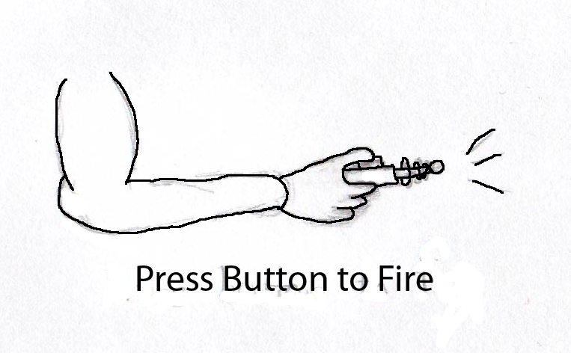

### Pistol

* **Hold:** One-handed. Bobs with the player's hand as they move.
* **Fire:** Small amount of recoil for a normal shot. Larger recoil for a charged shot. The barrel moves toward the hand when a shot is fired and moves back out shortly after the shot is fired.
* **Take out/Replace:** Reach down toward legs.

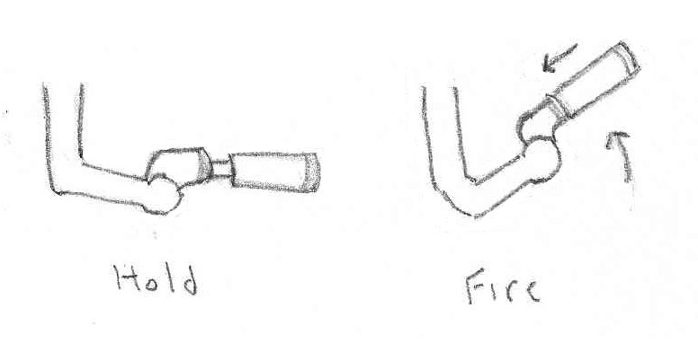

### Sniper Rifle

* **Hold:** Two-handed. Hands grip either side of the binocular sniper. Held at chest level.
* **Scope-in:** Move the binoculars to the eyes.
* **Fire:** Significant recoil. When scoped-in, the head whips backwards. When not scoped-in, the binocular sniper strikes the chest.
* **Take out/Replace:** Reach down toward legs.

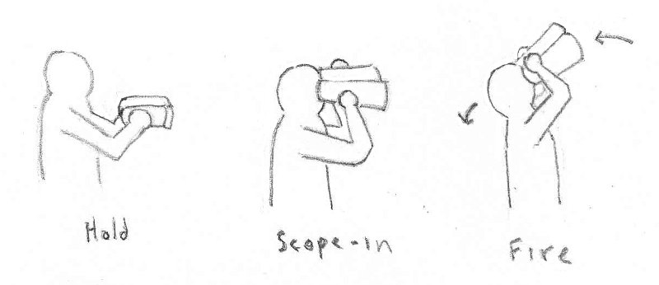

### Explosive Projectile Weapon

* **Hold:** Two-handed. Bobs as the player moves.
* **Fire:** Heavy recoil. Snaps the forward half of the gun upwards at the joint. Rebounds back into place after completing the upward motion.
* **Take out/Replace:** Reach down toward legs.

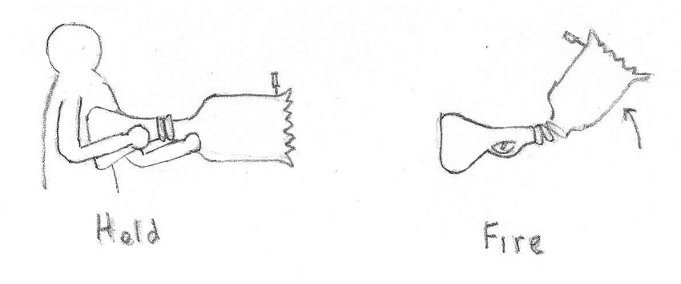

### Assault Rifle

* **Hold:** Two-handed. Bobs with the player's hands as they move.
* **Fire:** Very limited recoil. Moves slightly up and toward the player as it's shot.
* **Take out/Replace:** Reach down toward legs.

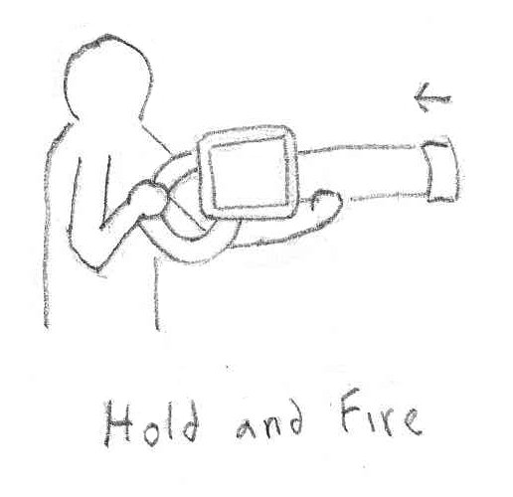

### Shotgun

* **Hold:** Two-handed. Bobs with the player's hands as they move.
* **Fire:** Heavy recoil moving the barrel significantly up and back. The three component guns reload sequentially.
* **Take out/Replace:** Reach down toward legs.

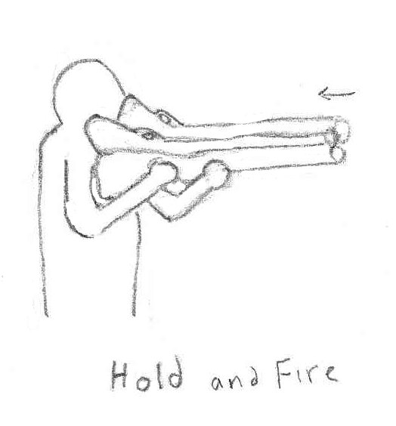

### Damage over Time Weapon

* **Hold:** Two-handed.
* **Fire:** No recoil. A beam projects through the lenses and to the target.
* **Take out/Replace:** Reach down toward legs.

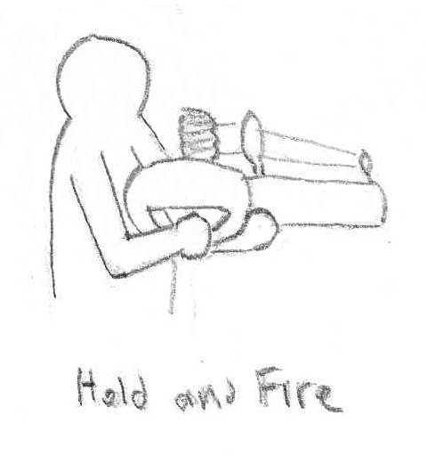

### Grenade

* **Hold:** Single-handed. Bobs with the player's hand as they move.
* **Shake:** Bends at the elbow up and down rapidly in a shaking motion.
* **Throw:** Extends the elbow and rotates the shoulder forward to throw the grenade.

